Project Implementation Report

IST659

FITNESS

DATABASE

Sanman M Yadav

[smyadav@syr.edu](mailto:smyadav@syr.edu)

218223603

CONTENTS

|  |  |  |
| --- | --- | --- |
| Sr.  No. | Title | Page No. |
| 1. | Business Rules | 3 |
| 2. | Major Data Questions | 4 |
| 3. | Project Summary | 6 |
| 4. | Entity And Attribute Table | 8 |
| 5. | Entity-Relationship Diagram | 14 |
| 6. | Creation of Tables | 16 |
| 7. | Interfaces | 48 |
| 8. | Report | 59 |
| 9. | Improvements on Recommendations | 61 |

BUSINESS RULES

1. Every member has a unique Member ID and Medical ID, which are different.
2. Every member has a smartwatch or smartphone which is on them at all times.
3. Nutrition Plan will have the nutritional instructions to follow as per the day of the week. Same goes for the Exercise Plan.
4. Real time data will be captured from the user on a 24 hrs. bases.
5. Here the members which only have a Gold Membership are considered.
6. On a particular day, the member will do different kinds of exercises. A new type of exercise will create a new record in the Exercise table. Same goes for the Nutrition table.

Major Data Questions:

Q1. What is the average amount of sets that each member does?

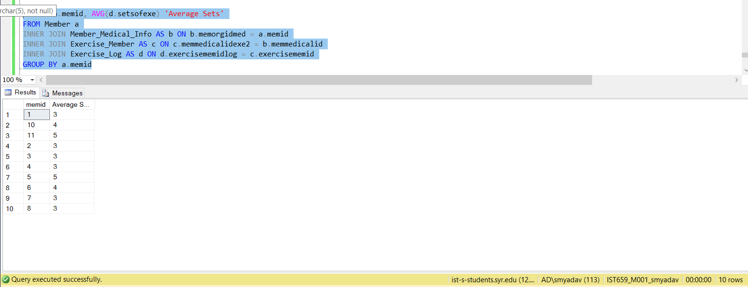

Q2. What is the average amount of calories consumed by the members?

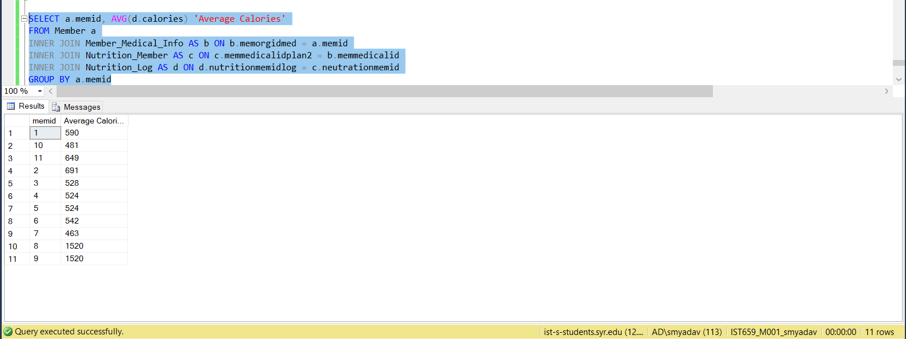

Q3. What is the average of Blood Pressure, Heart Beat, Total Steps, Time Active, for all the members?

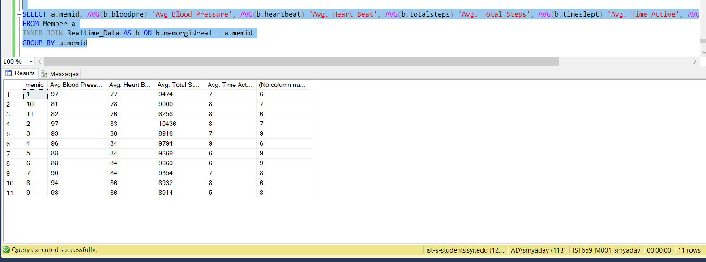

Q4. Information about the health of the members.

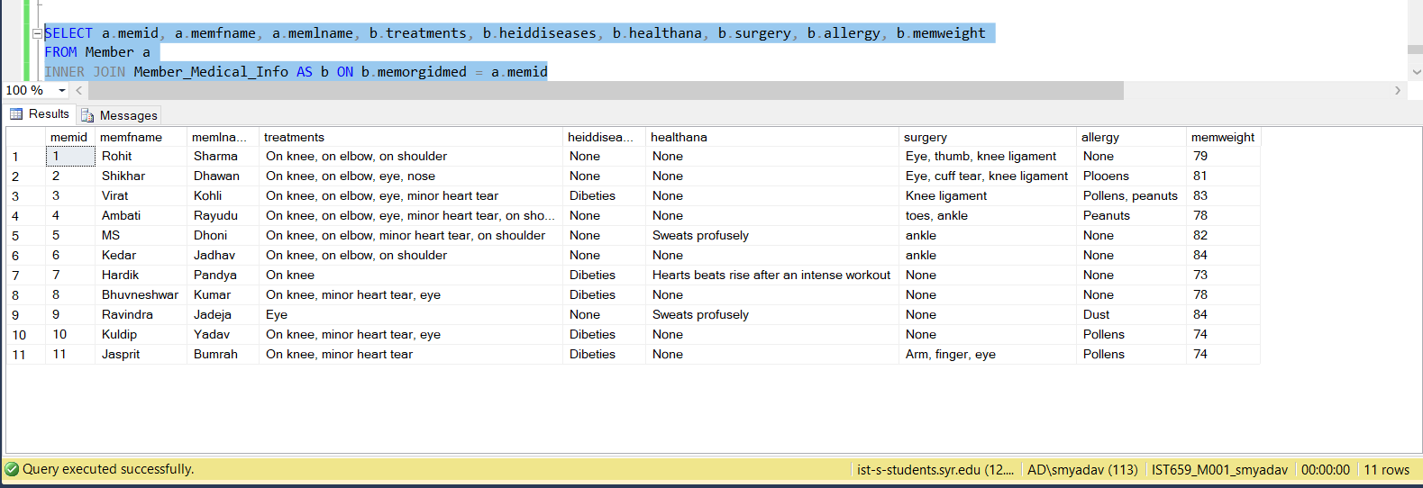

PROJECT SUMMARY

As a project I have decided to explore the Health Industry. Hence I have decided to focus on building a database for a Gym. A Gym database has a lot of potential of helping a person to get healthy and fit.

The Gym mostly provides health services. They have a wide range of services form training to nutritional which mostly include personal training, sports facilities, group exercise classes, exercise theater etc. The proposed database will not only maintain the information about the members of the gym but also of their nutrition and the amount of activity that one user does. This information will come in handy when changing ones nutrition to fit their training or to help an individual achieve personal goals.

The assumptions for the proposed system are that all the Gyms have a similar business model. All the services that are provided by all the Gyms are exactly the same. We also assume that all the Gym goers have a smartphone or a smartwatch on them at all the times.

The number of gym goers is increasing day by day. Total of 15% of the population of the world go to gym at least twice a week. As the role of technology in human life has increased there is more demand for technology in the fitness sector. The old database for the gym had only the information stored about the memberships in it. But people want to track their fitness now. They want to see trends in their workouts and nutrition. So there is a need for a database which can store the information about the daily report of their workouts and nutrition. In this project this is what I am trying to achieve. Built a database for gym goers so that they can track their progress in workouts and nutrition.

A normal gym with a traditional database can only help a person by giving him an area to workout. But the proposed database will do much more than that. It will have the ability to capture the user’s everyday data. With this little modification to the old gym database, it will be possible for the individual to track his progress and to take the steps accordingly to improve.

With the added features, a Nutritionist will be able to make some modifications in the diet to help the individual to achieve goals. This database can also be made available as a medical statement, ie, if an individual has a disease (not necessarily), like diabetes, it will be required for the user to follow a proper nutrition and exercise plan. Since the database will have all the required information about this, it will aid the doctor in making the adjustments to the treatment of that individual.

This would make the individual more informed about his body and will assist the individual in making more informed decisions.

This new database when implemented will help the organization grow as they can study the requirements of an individual and provide the necessary services to the customers instead of just providing unnecessary services.

This database will store the everyday information of the workouts and nutrition one person will do. In everyday workouts it will store the body part that is being exercised that day. Plus on this one can store the kinds of exercise for that body part one is doing with information of sets and repetitions of that exercise. This database also stores the information about the food one it eats. In everyday nutrition it will store which is the meal (Breakfast, Dinner etc.), the name of the dish and the calories in the food. This data will be stored on the everyday bases. This database will also store the information about the daily things like Blood Pressure, Heart Rate, Steps walked, Total Steps walked, total hours slept. This information will be stored on everyday bases.

The main users of this database will be the members of the gym. But since this database has the information about the exercise routine and nutrition one has, this database can also be used by a physician, a gym trainer and a nutritionist. These people can query the database to get the information of vitals, the sleeping pattern, the active pattern, the workout pattern, the nutrition pattern. This database can also be used by trainers and nutritionist to plan the workouts and nutrition for their members. The members then can query the database to find out what they are supposed to do for their workouts and nutrition. This informed database can be used to give analysis of the workouts and nutrition. The database is designed in such a way that, once enough data is stored, any kind of analysis from regression to logistic regression.

The functions that are considered and not included are recommendation systems. As the data will be mostly the historical data of the user it will be easier to build a recommendations system using one of many Machine Learning algorithms. The recommendations system can be useful if a person has no prior knowledge of nutrition or of working out to get the desired result.

Entity and Attribute Table

1. Member – This entity captures the information about a member in the gym.

|  |  |  |  |  |
| --- | --- | --- | --- | --- |
| Entity Name:  Member | Attribute Name | Field Type | NULL/NOT NULL | Explination |
| Primary Key | memid | VARCHAR | NOT NULL | Unique Identifier |
| Other Attributes | memfname | VARCHAR | NOT NULL | Member First Name |
|  | memlname | VARCHAR | NOT NULL | Member Last Name |
|  | memstreetno | INTEGER | NOT NULL | Street No |
|  | memstreetname | VARCHAR | NOT NULL | Street Name |
|  | memcity | VARCHAR | NOT NULL | City |
|  | memstate | VARCHAR | NOT NULL | State |
|  | memzip | VARCHAR | NOT NULL | Zip |
|  | memphoneno | VARCHAR | NOT NULL | Phone No |
|  | mememail | VARCHAR | NOT NULL | Email |
|  | memtype | VARCHAR | NOT NULL | Type of Membership |

1. Member_Medical_Info – This entity captures the information about the health of a member in the gym.

|  |  |  |  |  |
| --- | --- | --- | --- | --- |
| Entity Name:  Member_Medical_Info | Attribute Name | Field Type | NULL/NOT NULL | Explination |
| Primary Key | memmedicalid | VARCHAR | NOT NULL | Unique Identifier |
| Foreign Key - Member | memorgidmed | VARCHAR | NOT NULL | Foreign Key |
| Other Attributs | age | INTEGER | NOT NULL | Age of member |
|  | height | FLOAT | NOT NULL | Height of member |
|  | memweight | INTEGER | NOT NULL | Weight of member |
|  | dateofbirth | VARCHAR | NOT NULL | Date of birth of member |
|  | treatments | VARCHAR | NOT NULL | Treatments if the member has any. |
|  | heddiseases | VARCHAR | NOT NULL | If he has hereditary diseases. |
|  | healthanamoly | VARCHAR | NOT NULL | Any health anomaly member has. |
|  | allergies | VARCHAR | NOT NULL | If member has any allergies. |
|  | surgery | VARCHAR | NOT NULL | If the member has any operations done. |

1. Member Realtime Data – This entity captures the data on a 24hrs bases. It is able to store the information about blood pressure, heart beats etc. To collect this data the member must have a smart watch.

|  |  |  |  |  |
| --- | --- | --- | --- | --- |
| Entity Name:  Member Realtime Data | Attribute Name | Field Type | NULL/NOT NULL | Explination |
| Primary Key | memrealdataid | VARCHAR | NOT NULL | Unique Identifier |
| Foreign Key - Member | memorgidreal | VARCHAR | NOT NULL | Foreign Key |
| Other Attributes | timedate | INTEGER | NOT NULL | Gives the system time and date |
|  | bloodpre | INTEGER | NOT NULL | Takes the avg blood pressure |
|  | heartbeat | INTEGER | NOT NULL | Takes the avg heart beats |
|  | totalsteps | BIGINT | NOT NULL | Takes the total steps in a day |
|  | timeslept | INTEGER | NOT NULL | Takes the total time slept in a day |
|  | timeactive | INTEGER | NOT NULL | Takes total time active in a day. |

1. Exercise Plan – This entity helps the users to view and update the table which has the information of everyday routines for the member.

|  |  |  |  |  |
| --- | --- | --- | --- | --- |
| Entity Name:  Exercise Plan | Attribute Name | Field Type | NULL/NOT NULL | Explination |
| Primary Key | exerciseid | VARCHAR | NOT NULL | Unique Identifier |
| Foreign Key - Member_Medical_Info | memmedicalidexe | VARCHAR | NOT NULL | Foreign Key |
| Other Attributes | dayweek | VARCHAR | NOT NULL | Day of the week |
|  | instructions | VARCHAR | NOT NULL | Instructions to follow during one’s workout. |

1. Exercise_Member – This entity has the information about the day and time at which workout began on the day.

|  |  |  |  |  |
| --- | --- | --- | --- | --- |
| Entity Name:  Exercise_Member | Attribute Name | Field Type | NULL/NOT NULL | Explination |
| Primary Key | exercisememid | VARCHAR | NOT NULL | Unique Identifier |
| Foreign Key - Member_Medical_Info | memmedicalidexe2 | VARCHAR | NOT NULL | Foreign Key |
| Other Attributes | datetimes | DATETIME | NOT NULL | Date and time workout start. |
|  | dayweek | VARCHAR | NOT NULL | Day of the week |

1. Exercise_Log – This entity keeps the log of all the exercises done in a given day by the member.

|  |  |  |  |  |
| --- | --- | --- | --- | --- |
| Entity Name:  Exercise_Log | Attribute Name | Field Type | NULL/NOT NULL | Explination |
| Primary Key | logid | VARCHAR | NOT NULL | Unique Identifier |
| Foreign Key – Exercise Member | exercisememidlog | VARCHAR | NOT NULL | Foreign Key |
| Other Attributes | bodypart | VARCHAR | NOT NULL | Body Part Being Exercised |
|  | typeofexe | VARCHAR | NOT NULL | Type of Exercise |
|  | setsofexe | INTEGER | NOT NULL | Sets of each Type |
|  | repitations | INTEGER | NOT NULL | Repitaions for the Exercise |
|  | sweight | INTEGER | NOT NULL | Starting Weight |
|  | eweight | INTEGER | NOT NULL | Ending Weight |

1. Nutrition_Plan - This entity helps the users to view and update the table which has the information of everyday routines of meal for the member.

|  |  |  |  |  |
| --- | --- | --- | --- | --- |
| Entity Name:  Nutrition Plan | Attribute Name | Field Type | NULL/NOT NULL | Explination |
| Primary Key | nutritionid | VARCHAR | NOT NULL | Unique Identifier |
| Foreign Key - Member_Medical_Info | memmedicalidplan | VARCHAR | NOT NULL | Foreign Key |
| Other Attributes | dayweekplan | VARCHAR | NOT NULL | Day of the week |
|  | instructionspalan | VARCHAR | NOT NULL | Instructions to follow during the meals intake. |

1. Nutrition_Member – This entity has the information about the day and time at which the record is created began on the day.

|  |  |  |  |  |
| --- | --- | --- | --- | --- |
| Entity Name:  Nutrition_Member | Attribute Name | Field Type | NULL/NOT NULL | Explination |
| Primary Key | neutrationmemid | VARCHAR | NOT NULL | Unique Identifier |
| Foreign Key - Member_Medical_Info | memmedicalidplan2 | VARCHAR | NOT NULL | Foreign Key |
| Other Attributes | datetimesplan | DATETIME | NOT NULL | Date and time record was created start. |
|  | dayweekplan | VARCHAR | NOT NULL | Day of the week |

1. Nutrition_Log - This entity keeps the log of all meals that a member consumes during in a day.

|  |  |  |  |  |
| --- | --- | --- | --- | --- |
| Entity Name:  Nutrition Log | Attribute Name | Field Type | NULL/NOT NULL | Explination |
| Primary Key | logidnu | VARCHAR | NOT NULL | Unique Identifier |
| Foreign Key - Nutrition_Member | nutritionmemidlog | VARCHAR | NOT NULL | Foreign Key |
| Other Attributes | typeofmeal | VARCHAR | NOT NULL | Type of the meal |
|  | nameofmeal | VARCHAR | NOT NULL | Name of the meal |
|  | calories | INTEGER | NOT NULL | Total calories consumed during a meal. |
|  | timenow | VARCHAR | NOT NULL | Time of the meal. |

Entity-Relationship Diagram:

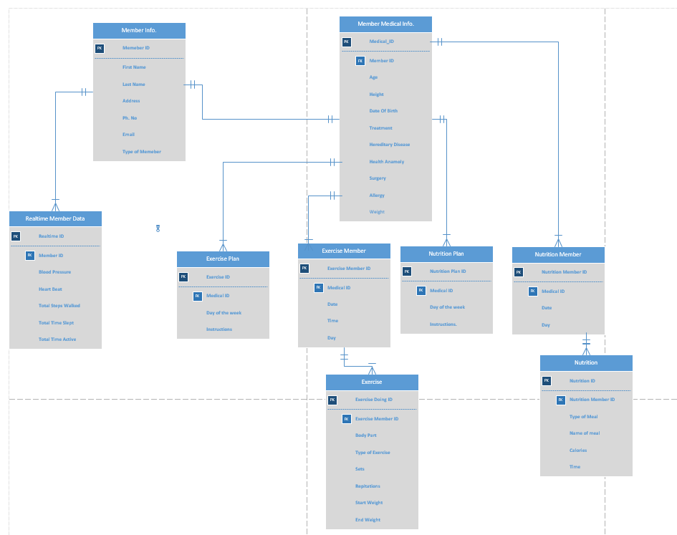

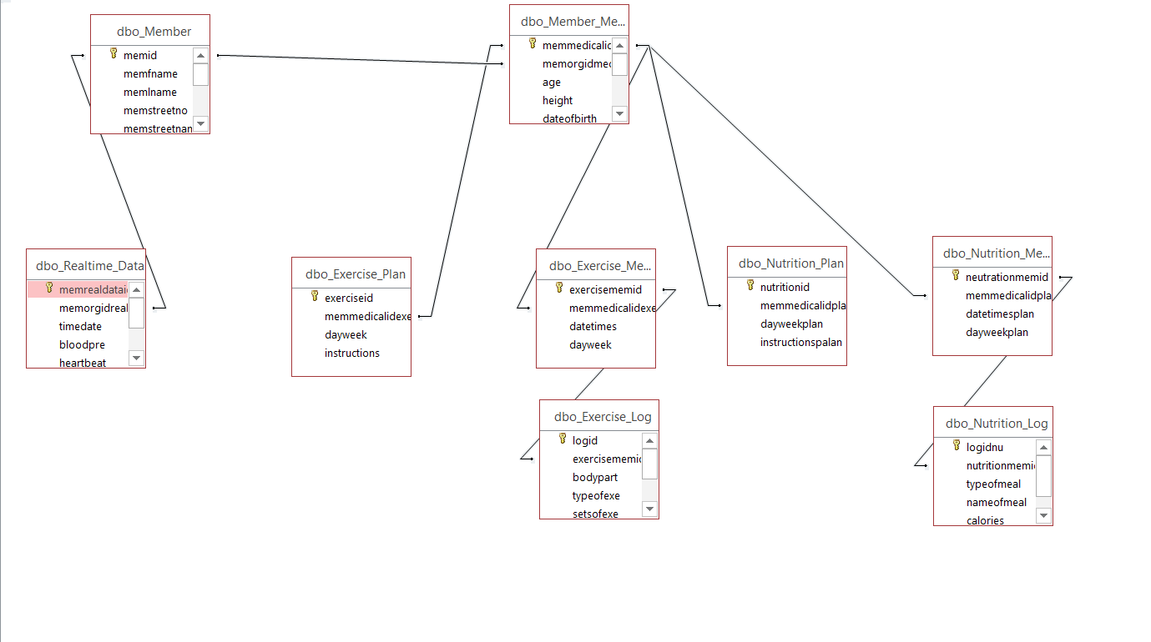

Creation of Tables

CREATE TABLE Member

(memid VARCHAR(20) NOT NULL,

memfname VARCHAR(20) NOT NULL,

memlname VARCHAR(20) NOT NULL,

memstreetno INTEGER NOT NULL,

memstreetname VARCHAR(40) NOT NULL,

memcity VARCHAR(15) NOT NULL,

memstate VARCHAR(15) NOT NULL,

memzip VARCHAR(7) NOT NULL,

memphoneno VARCHAR(15) NOT NULL,

mememail VARCHAR(30) NOT NULL,

memtype VARCHAR(5) NOT NULL CHECK ( memtype IN ('Bronze', 'Silver', 'Gold', 'Platinum'))

CONSTRAINT memid_PK PRIMARY KEY (memid)

);

CREATE TABLE Realtime_Data

(memrealdataid VARCHAR(20) NOT NULL,

memorgidreal VARCHAR(20) NOT NULL,

timedate DATETIME DEFAULT GETDATE() NOT NULL,

bloodpre INTEGER NOT NULL,

heartbeat INTEGER NOT NULL,

totalsteps BIGINT NOT NULL,

timeslept INTEGER NOT NULL,

timeactive INTEGER NOT NULL,

CONSTRAINT memrealdataid_PK PRIMARY KEY (memrealdataid),

CONSTRAINT Realtime_FK_memid FOREIGN KEY (memorgidreal) REFERENCES Member(memid)

);

CREATE TABLE Member_Medical_Info

(memmedicalid VARCHAR(20) NOT NULL,

memorgidmed VARCHAR(20) NOT NULL,

age INTEGER NOT NULL,

height FLOAT NOT NULL,

dateofbirth VARCHAR(12) NOT NULL,

treatments VARCHAR(200) NOT NULL,

heiddiseases VARCHAR(200) NOT NULL,

healthana VARCHAR(200) NOT NULL,

surgery VARCHAR(200) NOT NULL,

allergy VARCHAR(200) NOT NULL,

memweight INTEGER NOT NULL,

CONSTRAINT memmedicalid_PK PRIMARY KEY (memmedicalid),

CONSTRAINT Member_Medical_Info_FK_memid FOREIGN KEY (memorgidmed) REFERENCES Member(memid)

);

CREATE TABLE Exercise_Plan

(exerciseid VARCHAR(20) NOT NULL,

memmedicalidexe VARCHAR(20) NOT NULL,

dayweek VARCHAR(10) NOT NULL,

instructions VARCHAR(500) NOT NULL,

CONSTRAINT exerciseid_PK PRIMARY KEY (exerciseid),

CONSTRAINT Exercise_Plan_FK_memmedicalid FOREIGN KEY (memmedicalidexe) REFERENCES Member_Medical_Info(memmedicalid)

);

CREATE TABLE Exercise_Member

(exercisememid VARCHAR(20) NOT NULL,

memmedicalidexe2 VARCHAR(20) NOT NULL,

datetimes DATETIME DEFAULT GETDATE() NOT NULL,

dayweek VARCHAR(10) NOT NULL,

CONSTRAINT exercisememid_PK PRIMARY KEY (exercisememid),

CONSTRAINT Exercise_Member_FK_memmedicalid FOREIGN KEY (memmedicalidexe2) REFERENCES Member_Medical_Info(memmedicalid)

);

CREATE TABLE Exercise_Log

(logid VARCHAR(20) NOT NULL,

exercisememidlog VARCHAR(20) NOT NULL,

bodypart VARCHAR(20) NOT NULL,

typeofexe VARCHAR(30) NOT NULL,

setsofexe INTEGER NOT NULL,

repitations INTEGER NOT NULL,

sweight INTEGER NOT NULL,

eweight INTEGER NOT NULL,

CONSTRAINT logid_PK PRIMARY KEY (logid),

CONSTRAINT Exercise_Log_FK_memmedicalid FOREIGN KEY (exercisememidlog) REFERENCES Exercise_Member(exercisememid)

);

CREATE TABLE Nutrition_Plan

(nutritionid VARCHAR(20) NOT NULL,

memmedicalidplan VARCHAR(20) NOT NULL,

dayweekplan VARCHAR(10) NOT NULL,

instructionspalan VARCHAR(500) NOT NULL,

CONSTRAINT nutritionid_PK PRIMARY KEY (nutritionid),

CONSTRAINT Nutrition_Plan_FK_memmedicalid FOREIGN KEY (memmedicalidplan) REFERENCES Member_Medical_Info(memmedicalid)

);

CREATE TABLE Nutrition_Member

(neutrationmemid VARCHAR(20) NOT NULL,

memmedicalidplan2 VARCHAR(20) NOT NULL,

datetimesplan DATETIME DEFAULT GETDATE() NOT NULL,

dayweekplan VARCHAR(10) NOT NULL,

CONSTRAINT neutrationmemid_PK PRIMARY KEY (neutrationmemid),

CONSTRAINT Nutrition_Member_FK_memmedicalid FOREIGN KEY (memmedicalidplan2) REFERENCES Member_Medical_Info(memmedicalid)

);

CREATE TABLE Nutrition_Log

(logidnu VARCHAR(20) NOT NULL,

nutritionmemidlog VARCHAR(20) NOT NULL,

typeofmeal VARCHAR(20) NOT NULL,

nameofmeal VARCHAR(40) NOT NULL,

calories INTEGER NOT NULL,

timenow VARCHAR(15) NOT NULL,

CONSTRAINT logidnu_PK PRIMARY KEY (logidnu),

CONSTRAINT Nutrition_Log_FK_memmedicalid FOREIGN KEY (nutritionmemidlog) REFERENCES Nutrition_Member(neutrationmemid)

);

POPULATING THE TABLES WITH VALUES

INSERT INTO Member(memid, memfname, memlname, memstreetno, memstreetname, memcity, memstate, memzip, memphoneno, mememail, memtype) VALUES

('1', 'Rohit', 'Sharma', 264, 'Columbus Ave.', 'San Jose', 'California', '16755', '367-768-5435', 'rohitsharma@gmail.com' , 'Gold')

INSERT INTO Member(memid, memfname, memlname, memstreetno, memstreetname, memcity, memstate, memzip, memphoneno, mememail, memtype) VALUES

('2', 'Shikhar', 'Dhawan', 137, 'Syracuse Ave.', 'Boston', 'Boston State', '19872', '367-643-9935', 'shikhar@gmail.com' , 'Gold')

INSERT INTO Member(memid, memfname, memlname, memstreetno, memstreetname, memcity, memstate, memzip, memphoneno, mememail, memtype) VALUES

('3', 'Virat', 'Kohli', 183, 'Lancaster Ave.', 'Houston', 'Texas', '89734', '980-452-8562', 'viratkohli@gmail.com' , 'Gold')

INSERT INTO Member(memid, memfname, memlname, memstreetno, memstreetname, memcity, memstate, memzip, memphoneno, mememail, memtype) VALUES

('4', 'Ambati', 'Rayudu', 124, 'Comstock Ave.', 'Pawnee', 'indiana', '67356', '687-001-8976', 'ambatirayudu@gmail.com' , 'Gold')

INSERT INTO Member(memid, memfname, memlname, memstreetno, memstreetname, memcity, memstate, memzip, memphoneno, mememail, memtype) VALUES

('5', 'MS', 'Dhoni', 183, 'Columbus Ave.', 'Syracuse', 'New York', '13210', '315-378-6759', 'msd@gmail.com' , 'Gold')

INSERT INTO Member(memid, memfname, memlname, memstreetno, memstreetname, memcity, memstate, memzip, memphoneno, mememail, memtype) VALUES

('6', 'Kedar', 'Jadhav', 120, 'Westcott Ave.', 'Buffalo', 'New York', '4572', '897-567-3426', 'kedarjadhav@gmail.com' , 'Gold')

INSERT INTO Member(memid, memfname, memlname, memstreetno, memstreetname, memcity, memstate, memzip, memphoneno, mememail, memtype) VALUES

('7', 'Hardik', 'Pandya', 83, 'Gallery Ave.', 'Illiois', 'Chicago', '76588', '897-890-3426', 'hardikpandya@gmail.com' , 'Gold')

INSERT INTO Member(memid, memfname, memlname, memstreetno, memstreetname, memcity, memstate, memzip, memphoneno, mememail, memtype) VALUES

('8', 'Ravindra', 'Jadeja', 87, 'Comstock Ave.', 'Utica', 'New York', '67542', '765-930-2230', 'jaddu@gmail.com' , 'Gold')

INSERT INTO Member(memid, memfname, memlname, memstreetno, memstreetname, memcity, memstate, memzip, memphoneno, mememail, memtype) VALUES

('9', 'Bhuvneshwar', 'Kumar', 53, 'Beach Ave.', 'Syracuse', 'New York', '89754', '899-908-6543', 'kumarb@gmail.com' , 'Gold')

INSERT INTO Member(memid, memfname, memlname, memstreetno, memstreetname, memcity, memstate, memzip, memphoneno, mememail, memtype) VALUES

('10', 'Kuldip', 'Yadav', 19, 'Doctors Ave.', 'Syracuse', 'New York', '675088', '765-930-2231', 'kyadav@gmail.com' , 'Gold')

INSERT INTO Member(memid, memfname, memlname, memstreetno, memstreetname, memcity, memstate, memzip, memphoneno, mememail, memtype) VALUES

('11', 'Jasprit', 'Bumrah', 10, 'Columbus Ave.', 'Syracuse', 'New York', '65297', '765-930-9510', 'jazz@gmail.com' , 'Gold')

SELECT *

FROM Member

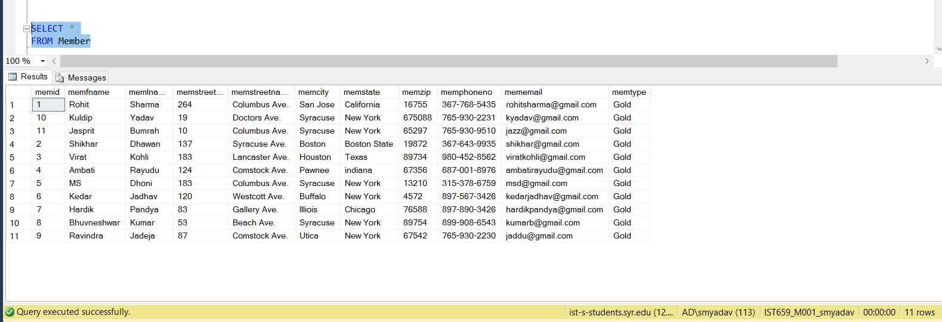

INSERT INTO Realtime_Data(memrealdataid, memorgidreal, timedate, bloodpre, heartbeat, totalsteps, timeslept, timeactive) VALUES

('1', '1', '2018-10-02 00:00:00.000', 99, 79, 8950, 7, 7)

INSERT INTO Realtime_Data(memrealdataid, memorgidreal, timedate, bloodpre, heartbeat, totalsteps, timeslept, timeactive) VALUES

('2', '1', '2018-10-03 00:00:00.000', 95, 76, 9999, 8, 6)

INSERT INTO Realtime_Data(memrealdataid, memorgidreal, timedate, bloodpre, heartbeat, totalsteps, timeslept, timeactive) VALUES

('3', '2', '2018-10-02 00:00:00.000', 93, 81, 10895, 8, 9)

INSERT INTO Realtime_Data(memrealdataid, memorgidreal, timedate, bloodpre, heartbeat, totalsteps, timeslept, timeactive) VALUES

('4', '2', '2018-10-03 00:00:00.000', 101, 86, 9978, 9, 6)

INSERT INTO Realtime_Data(memrealdataid, memorgidreal, timedate, bloodpre, heartbeat, totalsteps, timeslept, timeactive) VALUES

('5', '3', '2018-10-02 00:00:00.000', 91, 80, 7854, 7, 9)

INSERT INTO Realtime_Data(memrealdataid, memorgidreal, timedate, bloodpre, heartbeat, totalsteps, timeslept, timeactive) VALUES

('6', '3', '2018-10-03 00:00:00.000', 96, 80, 9979, 7, 9)

INSERT INTO Realtime_Data(memrealdataid, memorgidreal, timedate, bloodpre, heartbeat, totalsteps, timeslept, timeactive) VALUES

('7', '4', '2018-10-02 00:00:00.000', 96, 89, 9610, 9, 6)

INSERT INTO Realtime_Data(memrealdataid, memorgidreal, timedate, bloodpre, heartbeat, totalsteps, timeslept, timeactive) VALUES

('8', '4', '2018-10-03 00:00:00.000', 96, 80, 9979, 9, 7)

INSERT INTO Realtime_Data(memrealdataid, memorgidreal, timedate, bloodpre, heartbeat, totalsteps, timeslept, timeactive) VALUES

('9', '5', '2018-10-02 00:00:00.000', 89, 89, 9689, 8, 9)

INSERT INTO Realtime_Data(memrealdataid, memorgidreal, timedate, bloodpre, heartbeat, totalsteps, timeslept, timeactive) VALUES

('10', '5', '2018-10-03 00:00:00.000', 88, 80, 9650, 5, 10)

INSERT INTO Realtime_Data(memrealdataid, memorgidreal, timedate, bloodpre, heartbeat, totalsteps, timeslept, timeactive) VALUES

('11', '6', '2018-10-02 00:00:00.000', 89, 89, 9689, 8, 9)

INSERT INTO Realtime_Data(memrealdataid, memorgidreal, timedate, bloodpre, heartbeat, totalsteps, timeslept, timeactive) VALUES

('12', '6', '2018-10-03 00:00:00.000', 88, 80, 9650, 5, 10)

INSERT INTO Realtime_Data(memrealdataid, memorgidreal, timedate, bloodpre, heartbeat, totalsteps, timeslept, timeactive) VALUES

('13', '7', '2018-10-02 00:00:00.000', 92, 80, 9998, 7, 9)

INSERT INTO Realtime_Data(memrealdataid, memorgidreal, timedate, bloodpre, heartbeat, totalsteps, timeslept, timeactive) VALUES

('14', '7', '2018-10-03 00:00:00.000', 88, 89, 8710, 7, 8)

INSERT INTO Realtime_Data(memrealdataid, memorgidreal, timedate, bloodpre, heartbeat, totalsteps, timeslept, timeactive) VALUES

('15', '8', '2018-10-02 00:00:00.000', 91, 89, 8974, 8, 4)

INSERT INTO Realtime_Data(memrealdataid, memorgidreal, timedate, bloodpre, heartbeat, totalsteps, timeslept, timeactive) VALUES

('16', '8', '2018-10-03 00:00:00.000', 97, 84, 8891, 8, 8)

INSERT INTO Realtime_Data(memrealdataid, memorgidreal, timedate, bloodpre, heartbeat, totalsteps, timeslept, timeactive) VALUES

('17', '9', '2018-10-02 00:00:00.000', 91, 84, 8940, 5, 8)

INSERT INTO Realtime_Data(memrealdataid, memorgidreal, timedate, bloodpre, heartbeat, totalsteps, timeslept, timeactive) VALUES

('18', '9', '2018-10-03 00:00:00.000', 96, 89, 8888, 6, 8)

INSERT INTO Realtime_Data(memrealdataid, memorgidreal, timedate, bloodpre, heartbeat, totalsteps, timeslept, timeactive) VALUES

('19', '10', '2018-10-02 00:00:00.000', 82, 78, 8999, 9, 6)

INSERT INTO Realtime_Data(memrealdataid, memorgidreal, timedate, bloodpre, heartbeat, totalsteps, timeslept, timeactive) VALUES

('20', '10', '2018-10-03 00:00:00.000', 81, 79, 9002, 7, 8)

INSERT INTO Realtime_Data(memrealdataid, memorgidreal, timedate, bloodpre, heartbeat, totalsteps, timeslept, timeactive) VALUES

('21', '11', '2018-10-02 00:00:00.000', 83, 77, 6210, 8, 6)

INSERT INTO Realtime_Data(memrealdataid, memorgidreal, timedate, bloodpre, heartbeat, totalsteps, timeslept, timeactive) VALUES

('22', '11', '2018-10-03 00:00:00.000', 81, 76, 6302, 8, 7)

SELECT *

FROM Realtime_Data

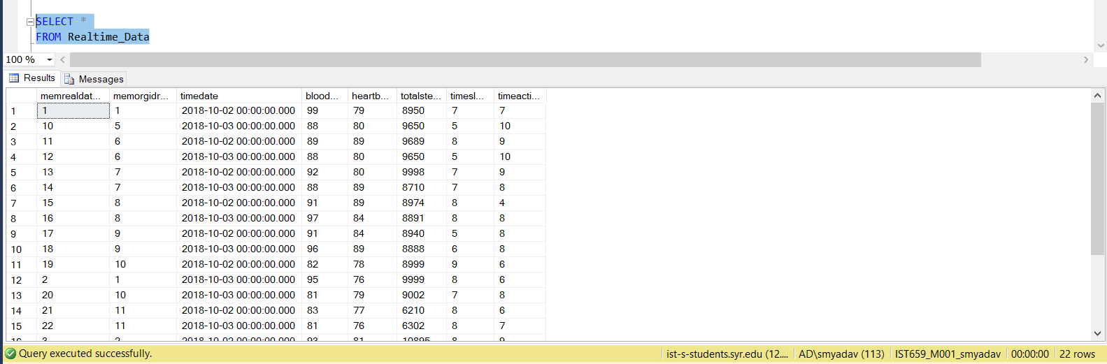

INSERT INTO Member_Medical_Info(memmedicalid, memorgidmed, age, height, dateofbirth, treatments, heiddiseases, healthana, surgery, allergy, memweight) VALUES

('101', '1', 29, 167, '1978-03-01', 'On knee, on elbow, on shoulder', 'None', 'None', 'Eye, thumb, knee ligament', 'None', 79)

INSERT INTO Member_Medical_Info(memmedicalid, memorgidmed, age, height, dateofbirth, treatments, heiddiseases, healthana, surgery, allergy, memweight) VALUES

('102', '2', 31, 171, '1980-04-01', 'On knee, on elbow, eye, nose', 'None', 'None', 'Eye, cuff tear, knee ligament', 'Plooens', 81)

INSERT INTO Member_Medical_Info(memmedicalid, memorgidmed, age, height, dateofbirth, treatments, heiddiseases, healthana, surgery, allergy, memweight) VALUES

('103', '3', 37, 179, '1970-04-01', 'On knee, on elbow, eye, minor heart tear', 'Dibeties', 'None', 'Knee ligament', 'Pollens, peanuts', 83)

INSERT INTO Member_Medical_Info(memmedicalid, memorgidmed, age, height, dateofbirth, treatments, heiddiseases, healthana, surgery, allergy, memweight) VALUES

('104', '4', 21, 181, '1985-09-01', 'On knee, on elbow, eye, minor heart tear, on shoulder', 'None', 'None', 'toes, ankle', 'Peanuts', 78)

INSERT INTO Member_Medical_Info(memmedicalid, memorgidmed, age, height, dateofbirth, treatments, heiddiseases, healthana, surgery, allergy, memweight) VALUES

('105', '5', 26, 169, '1978-11-01', 'On knee, on elbow, minor heart tear, on shoulder', 'None', 'Sweats profusely', 'ankle', 'None', 82)

INSERT INTO Member_Medical_Info(memmedicalid, memorgidmed, age, height, dateofbirth, treatments, heiddiseases, healthana, surgery, allergy, memweight) VALUES

('106', '6', 21, 174, '1982-05-01', 'On knee, on elbow, on shoulder', 'None', 'None', 'ankle', 'None', 84)

INSERT INTO Member_Medical_Info(memmedicalid, memorgidmed, age, height, dateofbirth, treatments, heiddiseases, healthana, surgery, allergy, memweight) VALUES

('107', '7', 25, 164, '1980-08-01', 'On knee', 'Dibeties', 'Hearts beats rise after an intense workout', 'None', 'None', 73)

INSERT INTO Member_Medical_Info(memmedicalid, memorgidmed, age, height, dateofbirth, treatments, heiddiseases, healthana, surgery, allergy, memweight) VALUES

('108', '8', 19, 171, '1998-10-01', 'On knee, minor heart tear, eye', 'Dibeties', 'None', 'None', 'None', 78)

INSERT INTO Member_Medical_Info(memmedicalid, memorgidmed, age, height, dateofbirth, treatments, heiddiseases, healthana, surgery, allergy, memweight) VALUES

('109', '9', 30, 186, '1985-11-01', 'Eye', 'None', 'Sweats profusely', 'None', 'Dust', 84)

INSERT INTO Member_Medical_Info(memmedicalid, memorgidmed, age, height, dateofbirth, treatments, heiddiseases, healthana, surgery, allergy, memweight) VALUES

('110', '10', 23, 183, '1991-04-01', 'On knee, minor heart tear, eye', 'Dibeties', 'None', 'None', 'Pollens', 74)

INSERT INTO Member_Medical_Info(memmedicalid, memorgidmed, age, height, dateofbirth, treatments, heiddiseases, healthana, surgery, allergy, memweight) VALUES

('111', '11', 34, 169, '1981-09-01', 'On knee, minor heart tear', 'Dibeties', 'None', 'Arm, finger, eye', 'Pollens', 74)

SELECT *

FROM Member_Medical_Info

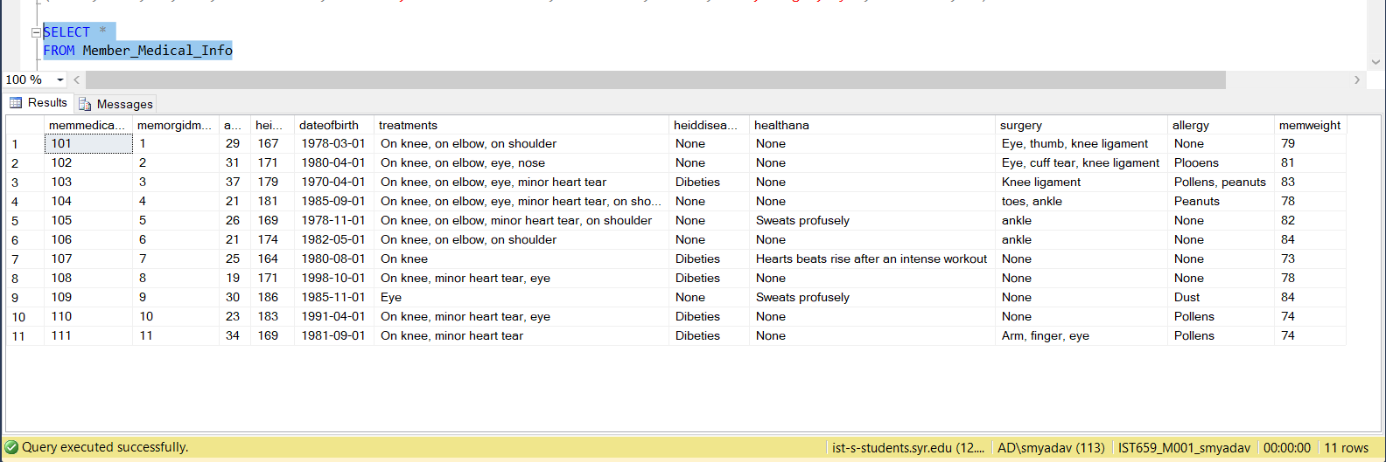

INSERT INTO Exercise_Plan(exerciseid, memmedicalidexe, dayweek, instructions) VALUES

('000001', '101', 'Monday', 'CHEST - Flat Dumbbells 4-20, Flat Bench 4-18, Incline Bench 3-15, Incline Dumbbells 3-15, Decline Bench 2-18')

INSERT INTO Exercise_Plan(exerciseid, memmedicalidexe, dayweek, instructions) VALUES

('000002', '101', 'Tuesday', 'ARMS - Bicep Curl 4-15, Bicep Concentration 3-25, Dumbbell culr 4-30, Close Grip Bench 3-20, Dumbbell Overhead 3-18')

INSERT INTO Exercise_Plan(exerciseid, memmedicalidexe, dayweek, instructions) VALUES

('000003', '101', 'Wednesday', 'LOWER BODY - Full Squats 4-20, Box Squats 4-25, Lunges 4-20, Plies Squats 3-20, Side Lunges 4-20, Calf Rises')

INSERT INTO Exercise_Plan(exerciseid, memmedicalidexe, dayweek, instructions) VALUES

('000004', '101', 'Thursday', 'BACK - Deadlift 5-15, Pull Up 4-20, Bar Row 3-15, Pull Down 4-25, Reverse Grip Row 3-10, T-Bar Row 3-10')

INSERT INTO Exercise_Plan(exerciseid, memmedicalidexe, dayweek, instructions) VALUES

('000005', '101', 'Friday', 'SHOULDER - Overhead Press 4-20, Push Press 4-15, Fly 3-15, Lateral Rises 4-20, Rear Delt Rises 3-15, Front Rises 4-20')

INSERT INTO Exercise_Plan(exerciseid, memmedicalidexe, dayweek, instructions) VALUES

('000006', '101', 'Saturday', 'CROSSFIT - Sumo Deadlift 3-25, Shoulder Press 3-20, Overhead Squat 3-20, Push Jerk 3-15, Push Press 3-20')

INSERT INTO Exercise_Plan(exerciseid, memmedicalidexe, dayweek, instructions) VALUES

('000007', '102', 'Monday', 'LOWER BODY - Squats 5-15, Lunges 4-15, Wide Squats 4-18, Front Squats 5-15')

INSERT INTO Exercise_Plan(exerciseid, memmedicalidexe, dayweek, instructions) VALUES

('000008', '102', 'Tuesday', 'SHOULDER - Lateral Rises 5-15, Front Rises 4-15, Overhead Press 4-18, Push Press 5-15, Fly 3-15')

INSERT INTO Exercise_Plan(exerciseid, memmedicalidexe, dayweek, instructions) VALUES

('000009', '102', 'Wednesday', 'ARMS - Bicep Curl 5-15, Bicep Machine 4-15, Tricep Extension 4-18, AZ Bar 5-15, Tricep 3 Types 3-15')

INSERT INTO Exercise_Plan(exerciseid, memmedicalidexe, dayweek, instructions) VALUES

('000010', '102', 'Thursday', ' CHEST - Flat Bench 4-20, Flat Dumbbells 4-18, Incline Bench 3-15, Incline Dumbbells 3-15, Decline BEnch 2-18')

INSERT INTO Exercise_Plan(exerciseid, memmedicalidexe, dayweek, instructions) VALUES

('000011', '102', 'Friday', 'LOWER BODY - Full Squats 4-20, Box Squats 4-25, Lunges 4-20, Side Lunges 4-20, Plie Squats 4-20, Calf Rises 5-40')

INSERT INTO Exercise_Plan(exerciseid, memmedicalidexe, dayweek, instructions) VALUES

('000012', '102', 'Saturday', 'CROSSFIT - Sumo Deadlift 3-25, Shoulder Press 3-20, Overhead Squats 3-20, Push Jerk 3-15, Push Press 3-20')

INSERT INTO Exercise_Plan(exerciseid, memmedicalidexe, dayweek, instructions) VALUES

('000013', '103', 'Monday', 'ARMS - AZ Bar 3-15, Bicep Curl 3-14, Bicep Machine 3-20, Tricep 3 Types 4-15, Tricep Extension 3-15')

INSERT INTO Exercise_Plan(exerciseid, memmedicalidexe, dayweek, instructions) VALUES

('000014', '104', 'Monday', 'SHOULDER - Shoulder Machine 4-20, Shoulder Dumbbell 4-20, Dumbbell Fly 3-15, Dumbbell Frontrises 3-20, Dumbbell Siderises 4-15')

INSERT INTO Exercise_Plan(exerciseid, memmedicalidexe, dayweek, instructions) VALUES

('000015', '105', 'Monday', 'CORE - legrises 5-20, Crunches 5-25, Side Bends 5-30, Jackknife 5-30, Reverse Crunch 5-25, Wiper Crunches 5-25')

INSERT INTO Exercise_Plan(exerciseid, memmedicalidexe, dayweek, instructions) VALUES

('000016', '106', 'Monday', 'LOWER BODY - Wide Squats 4-18, Squats 5-15, Front Squats 5-15, Lunges 4-15')

INSERT INTO Exercise_Plan(exerciseid, memmedicalidexe, dayweek, instructions) VALUES

('000017', '107', 'Monday', 'SHOULDER - Shoulder Machine 4-20, Dumbbell Fly 3-15, Shoulder Dumbbell 4-20, Barbell Siderises 4-15, Dumbbell Frontrises 3-20')

INSERT INTO Exercise_Plan(exerciseid, memmedicalidexe, dayweek, instructions) VALUES

('000018', '108', 'Monday', 'CHEST - Flat Dumbbells 4-18, Incline Bench 3-15, Flat Bench 4-20, Decline Bench 2-18, Incline Dumbbells 3-15')

INSERT INTO Exercise_Plan(exerciseid, memmedicalidexe, dayweek, instructions) VALUES

('000019', '109', 'Monday', 'CORE - Wiper Crunch 5-25, Leg Rises 5-20, Side Bends 5-30, Jackkinfe 5-30, Crunches 5-25, Reverse Crunches 5-25')

INSERT INTO Exercise_Plan(exerciseid, memmedicalidexe, dayweek, instructions) VALUES

('000020', '110', 'Monday', 'LOWER BODY - Lunges 4-25, Wide Squats 4-18, Squats 5-15, Front Squats 5-15')

INSERT INTO Exercise_Plan(exerciseid, memmedicalidexe, dayweek, instructions) VALUES

('000021', '111', 'Monday', 'CORE - Wiper Crunches 5-25, leg Rises 5-20, Side Bends 5-30, Reverse Crunches 5-25, Crunches 5-25, Jackkinfe 5-30')

SELECT *

FROM Exercise_Plan

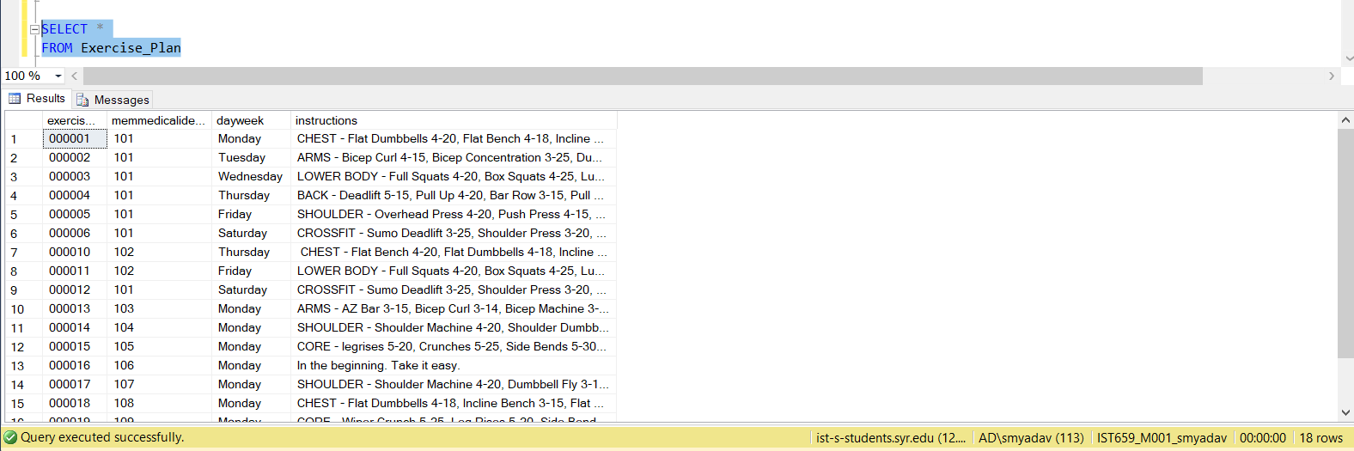

INSERT INTO Exercise_Member(exercisememid, memmedicalidexe2, datetimes, dayweek) VALUES

('1001', '101', '2018-10-03 19:01:45.000', 'Monday')

INSERT INTO Exercise_Member(exercisememid, memmedicalidexe2, datetimes, dayweek) VALUES

('1002', '102', '2018-10-03 09:09:45.000', 'Monday')

INSERT INTO Exercise_Member(exercisememid, memmedicalidexe2, datetimes, dayweek) VALUES

('1003', '103', '2018-10-03 13:13:40.000', 'Monday')

INSERT INTO Exercise_Member(exercisememid, memmedicalidexe2, datetimes, dayweek) VALUES

('1004', '104', '2018-10-03 20:20:40.000', 'Monday')

INSERT INTO Exercise_Member(exercisememid, memmedicalidexe2, datetimes, dayweek) VALUES

('1005', '105', '2018-10-03 20:01:36.000', 'Monday')

INSERT INTO Exercise_Member(exercisememid, memmedicalidexe2, datetimes, dayweek) VALUES

('1006', '106', '2018-10-03 01:01:01.000', 'Monday')

INSERT INTO Exercise_Member(exercisememid, memmedicalidexe2, datetimes, dayweek) VALUES

('1007', '107', '2018-10-03 05:03:10.000', 'Monday')

INSERT INTO Exercise_Member(exercisememid, memmedicalidexe2, datetimes, dayweek) VALUES

('1008', '108', '2018-10-03 07:54:55.000', 'Monday')

INSERT INTO Exercise_Member(exercisememid, memmedicalidexe2, datetimes, dayweek) VALUES

('1009', '109', '2018-10-03 07:02:55.000', 'Monday')

INSERT INTO Exercise_Member(exercisememid, memmedicalidexe2, datetimes, dayweek) VALUES

('1010', '110', '2018-10-03 09:08:39.000', 'Monday')

INSERT INTO Exercise_Member(exercisememid, memmedicalidexe2, datetimes, dayweek) VALUES

('1011', '111', '2018-10-03 15:08:59.000', 'Monday')

INSERT INTO Exercise_Member(exercisememid, memmedicalidexe2, datetimes, dayweek) VALUES

('1012', '101', '2018-10-04 20:04:29.000', 'Tuesday')

INSERT INTO Exercise_Member(exercisememid, memmedicalidexe2, datetimes, dayweek) VALUES

('1013', '101', '2018-10-04 19:45:35.000', 'Wednesday')

INSERT INTO Exercise_Member(exercisememid, memmedicalidexe2, datetimes, dayweek) VALUES

('1014', '101', '2018-10-06 21:45:00.000', 'Thursday')

INSERT INTO Exercise_Member(exercisememid, memmedicalidexe2, datetimes, dayweek) VALUES

('1015', '101', '2018-10-07 20:20:20.000', 'Friday')

INSERT INTO Exercise_Member(exercisememid, memmedicalidexe2, datetimes, dayweek) VALUES

('1016', '101', '2018-10-08 14:26:29.000', 'Saturday')

INSERT INTO Exercise_Member(exercisememid, memmedicalidexe2, datetimes, dayweek) VALUES

('1017', '102', '2018-10-04 10:10:10.000', 'Tuesday')

INSERT INTO Exercise_Member(exercisememid, memmedicalidexe2, datetimes, dayweek) VALUES

('1018', '102', '2018-10-05 09:09:09.000', 'Wednesday')

INSERT INTO Exercise_Member(exercisememid, memmedicalidexe2, datetimes, dayweek) VALUES

('1019', '102', '2018-10-06 10:01:00.000', 'Thursday')

INSERT INTO Exercise_Member(exercisememid, memmedicalidexe2, datetimes, dayweek) VALUES

('1020', '102', '2018-10-07 11:00:20.000', 'Friday')

INSERT INTO Exercise_Member(exercisememid, memmedicalidexe2, datetimes, dayweek) VALUES

('1021', '102', '2018-10-08 07:54:54.000', 'Saturday')

SELECT *

FROM Exercise_Member

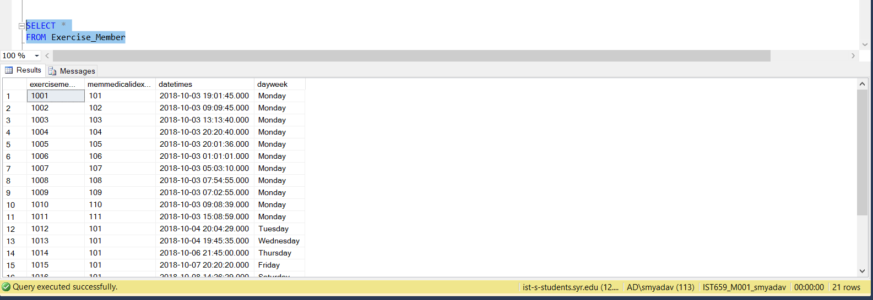

INSERT INTO Exercise_Log(logid, exercisememidlog, bodypart, typeofexe, setsofexe, repitations, sweight, eweight) VALUES

('10001', '1001', 'Chest', 'Flat Bench', 4, 20, 35, 60)

INSERT INTO Exercise_Log(logid, exercisememidlog, bodypart, typeofexe, setsofexe, repitations, sweight, eweight) VALUES

('10002', '1001', 'Chest', 'Flat Dumbells', 4, 18, 40, 70)

INSERT INTO Exercise_Log(logid, exercisememidlog, bodypart, typeofexe, setsofexe, repitations, sweight, eweight) VALUES

('10003', '1001', 'Chest', 'Incline Bench', 3, 15, 15, 35)

INSERT INTO Exercise_Log(logid, exercisememidlog, bodypart, typeofexe, setsofexe, repitations, sweight, eweight) VALUES

('10004', '1001', 'Chest', 'Incline Dumbells', 3, 15, 20, 40)

INSERT INTO Exercise_Log(logid, exercisememidlog, bodypart, typeofexe, setsofexe, repitations, sweight, eweight) VALUES

('10005', '1001', 'Chest', 'Decline Bench', 2, 18, 20, 35)

INSERT INTO Exercise_Log(logid, exercisememidlog, bodypart, typeofexe, setsofexe, repitations, sweight, eweight) VALUES

('10006', '1002', 'Lower Body', 'Squats', 5, 15, 30, 60)

INSERT INTO Exercise_Log(logid, exercisememidlog, bodypart, typeofexe, setsofexe, repitations, sweight, eweight) VALUES

('10007', '1002', 'Lower Body', 'Lunges', 4, 15, 15, 30)

INSERT INTO Exercise_Log(logid, exercisememidlog, bodypart, typeofexe, setsofexe, repitations, sweight, eweight) VALUES

('10008', '1002', 'Lower Body', 'Wide Squats', 4, 18, 35, 60)

INSERT INTO Exercise_Log(logid, exercisememidlog, bodypart, typeofexe, setsofexe, repitations, sweight, eweight) VALUES

('10009', '1002', 'Lower Body', 'Front Squats', 5, 15, 20, 35)

INSERT INTO Exercise_Log(logid, exercisememidlog, bodypart, typeofexe, setsofexe, repitations, sweight, eweight) VALUES

('100010', '1003', 'Arms', 'A-Z Bar', 3, 15, 7, 20)

INSERT INTO Exercise_Log(logid, exercisememidlog, bodypart, typeofexe, setsofexe, repitations, sweight, eweight) VALUES

('100011', '1003', 'Arms', 'Bicep Curl', 3, 14, 10, 25)

INSERT INTO Exercise_Log(logid, exercisememidlog, bodypart, typeofexe, setsofexe, repitations, sweight, eweight) VALUES

('100012', '1003', 'Arms', 'Bicep Machine', 3, 20, 12, 30)

INSERT INTO Exercise_Log(logid, exercisememidlog, bodypart, typeofexe, setsofexe, repitations, sweight, eweight) VALUES

('100013', '1003', 'Arms', 'Tricep 3 types', 4, 15, 10, 25)

INSERT INTO Exercise_Log(logid, exercisememidlog, bodypart, typeofexe, setsofexe, repitations, sweight, eweight) VALUES

('100014', '1003', 'Arms', 'Triceps Extension', 3, 15, 13, 25)

INSERT INTO Exercise_Log(logid, exercisememidlog, bodypart, typeofexe, setsofexe, repitations, sweight, eweight) VALUES

('100015', '1004', 'Shoulder', 'Shoulder Machine', 4, 20, 15, 40)

INSERT INTO Exercise_Log(logid, exercisememidlog, bodypart, typeofexe, setsofexe, repitations, sweight, eweight) VALUES

('100016', '1004', 'Shoulder', 'Shoulder Dumbbell', 4, 20, 12, 35)

INSERT INTO Exercise_Log(logid, exercisememidlog, bodypart, typeofexe, setsofexe, repitations, sweight, eweight) VALUES

('100017', '1004', 'Shoulder', 'Dumbbell Fly', 3, 15, 7, 12)

INSERT INTO Exercise_Log(logid, exercisememidlog, bodypart, typeofexe, setsofexe, repitations, sweight, eweight) VALUES

('100018', '1004', 'Shoulder', 'Dumbbell frontrises', 3, 20, 10, 25)

INSERT INTO Exercise_Log(logid, exercisememidlog, bodypart, typeofexe, setsofexe, repitations, sweight, eweight) VALUES

('100019', '1004', 'Shoulder', 'Barbell siderises', 4, 15, 15, 30)

INSERT INTO Exercise_Log(logid, exercisememidlog, bodypart, typeofexe, setsofexe, repitations, sweight, eweight) VALUES

('100020', '1005', 'Core', 'Leg rises', 5, 20, 0, 0)

INSERT INTO Exercise_Log(logid, exercisememidlog, bodypart, typeofexe, setsofexe, repitations, sweight, eweight) VALUES

('100021', '1005', 'Core', 'Crunches', 5, 25, 0, 0)

INSERT INTO Exercise_Log(logid, exercisememidlog, bodypart, typeofexe, setsofexe, repitations, sweight, eweight) VALUES

('100022', '1005', 'Core', 'Side Bends', 5, 30, 15, 30)

INSERT INTO Exercise_Log(logid, exercisememidlog, bodypart, typeofexe, setsofexe, repitations, sweight, eweight) VALUES

('100023', '1005', 'Core', 'Jackknife', 5, 30, 0, 0)

INSERT INTO Exercise_Log(logid, exercisememidlog, bodypart, typeofexe, setsofexe, repitations, sweight, eweight) VALUES

('100024', '1005', 'Core', 'Reverse crunch', 5, 25, 0, 0)

INSERT INTO Exercise_Log(logid, exercisememidlog, bodypart, typeofexe, setsofexe, repitations, sweight, eweight) VALUES

('100025', '1005', 'Core', 'Wiper Crunch', 5, 25, 0, 0)

INSERT INTO Exercise_Log(logid, exercisememidlog, bodypart, typeofexe, setsofexe, repitations, sweight, eweight) VALUES

('100026', '1006', 'Lower Body', 'Wide Squats', 4, 18, 35, 60)

INSERT INTO Exercise_Log(logid, exercisememidlog, bodypart, typeofexe, setsofexe, repitations, sweight, eweight) VALUES

('100027', '1006', 'Lower Body', 'Squats', 5, 15, 30, 60)

INSERT INTO Exercise_Log(logid, exercisememidlog, bodypart, typeofexe, setsofexe, repitations, sweight, eweight) VALUES

('100028', '1006', 'Lower Body', 'Front Squats', 5, 15, 20, 35)

INSERT INTO Exercise_Log(logid, exercisememidlog, bodypart, typeofexe, setsofexe, repitations, sweight, eweight) VALUES

('100029', '1006', 'Lower Body', 'Lunges', 4, 15, 15, 30)

INSERT INTO Exercise_Log(logid, exercisememidlog, bodypart, typeofexe, setsofexe, repitations, sweight, eweight) VALUES

('100030', '1007', 'Shoulder', 'Shoulder Machine', 4, 20, 15, 40)

INSERT INTO Exercise_Log(logid, exercisememidlog, bodypart, typeofexe, setsofexe, repitations, sweight, eweight) VALUES

('100031', '1007', 'Shoulder', 'Dumbbell Fly', 3, 15, 7, 12)

INSERT INTO Exercise_Log(logid, exercisememidlog, bodypart, typeofexe, setsofexe, repitations, sweight, eweight) VALUES

('100032', '1007', 'Shoulder', 'Shoulder Dumbbell', 4, 20, 12, 35)

INSERT INTO Exercise_Log(logid, exercisememidlog, bodypart, typeofexe, setsofexe, repitations, sweight, eweight) VALUES

('100033', '1007', 'Shoulder', 'Barbell siderises', 4, 15, 15, 30)

INSERT INTO Exercise_Log(logid, exercisememidlog, bodypart, typeofexe, setsofexe, repitations, sweight, eweight) VALUES

('100034', '1007', 'Shoulder', 'Dumbbell frontrises', 3, 20, 10, 25)

INSERT INTO Exercise_Log(logid, exercisememidlog, bodypart, typeofexe, setsofexe, repitations, sweight, eweight) VALUES

('100035', '1008', 'Chest', 'Flat Dumbells', 4, 18, 40, 70)

INSERT INTO Exercise_Log(logid, exercisememidlog, bodypart, typeofexe, setsofexe, repitations, sweight, eweight) VALUES

('100036', '1008', 'Chest', 'Incline Bench', 3, 15, 15, 35)

INSERT INTO Exercise_Log(logid, exercisememidlog, bodypart, typeofexe, setsofexe, repitations, sweight, eweight) VALUES

('100037', '1008', 'Chest', 'Flat Bench', 4, 20, 35, 60)

INSERT INTO Exercise_Log(logid, exercisememidlog, bodypart, typeofexe, setsofexe, repitations, sweight, eweight) VALUES

('100038', '1008', 'Chest', 'Decline Bench', 2, 18, 20, 35)

INSERT INTO Exercise_Log(logid, exercisememidlog, bodypart, typeofexe, setsofexe, repitations, sweight, eweight) VALUES

('100039', '1008', 'Chest', 'Incline Dumbells', 3, 15, 20, 40)

INSERT INTO Exercise_Log(logid, exercisememidlog, bodypart, typeofexe, setsofexe, repitations, sweight, eweight) VALUES

('100040', '1009', 'Core', 'Wiper Crunch', 5, 25, 0, 0)

INSERT INTO Exercise_Log(logid, exercisememidlog, bodypart, typeofexe, setsofexe, repitations, sweight, eweight) VALUES

('100041', '1009', 'Core', 'Leg rises', 5, 20, 0, 0)

INSERT INTO Exercise_Log(logid, exercisememidlog, bodypart, typeofexe, setsofexe, repitations, sweight, eweight) VALUES

('100042', '1009', 'Core', 'Side Bends', 5, 30, 15, 30)

INSERT INTO Exercise_Log(logid, exercisememidlog, bodypart, typeofexe, setsofexe, repitations, sweight, eweight) VALUES

('100043', '1009', 'Core', 'Jackknife', 5, 30, 0, 0)

INSERT INTO Exercise_Log(logid, exercisememidlog, bodypart, typeofexe, setsofexe, repitations, sweight, eweight) VALUES

('100044', '1009', 'Core', 'Crunches', 5, 25, 0, 0)

INSERT INTO Exercise_Log(logid, exercisememidlog, bodypart, typeofexe, setsofexe, repitations, sweight, eweight) VALUES

('100045', '1009', 'Core', 'Reverse crunch', 5, 25, 0, 0)

INSERT INTO Exercise_Log(logid, exercisememidlog, bodypart, typeofexe, setsofexe, repitations, sweight, eweight) VALUES

('100046', '1010', 'Lower Body', 'Wide Squats', 4, 18, 35, 60)

INSERT INTO Exercise_Log(logid, exercisememidlog, bodypart, typeofexe, setsofexe, repitations, sweight, eweight) VALUES

('100047', '1010', 'Lower Body', 'Squats', 5, 15, 30, 60)

INSERT INTO Exercise_Log(logid, exercisememidlog, bodypart, typeofexe, setsofexe, repitations, sweight, eweight) VALUES

('100048', '1010', 'Lower Body', 'Front Squats', 5, 15, 20, 35)

INSERT INTO Exercise_Log(logid, exercisememidlog, bodypart, typeofexe, setsofexe, repitations, sweight, eweight) VALUES

('100049', '1010', 'Lower Body', 'Lunges', 4, 15, 15, 30)

INSERT INTO Exercise_Log(logid, exercisememidlog, bodypart, typeofexe, setsofexe, repitations, sweight, eweight) VALUES

('100050', '1011', 'Core', 'Wiper Crunch', 5, 25, 0, 0)

INSERT INTO Exercise_Log(logid, exercisememidlog, bodypart, typeofexe, setsofexe, repitations, sweight, eweight) VALUES

('100051', '1011', 'Core', 'Leg rises', 5, 20, 0, 0)

INSERT INTO Exercise_Log(logid, exercisememidlog, bodypart, typeofexe, setsofexe, repitations, sweight, eweight) VALUES

('100052', '1011', 'Core', 'Side Bends', 5, 30, 15, 30)

INSERT INTO Exercise_Log(logid, exercisememidlog, bodypart, typeofexe, setsofexe, repitations, sweight, eweight) VALUES

('100053', '1011', 'Core', 'Reverse crunch', 5, 25, 0, 0)

INSERT INTO Exercise_Log(logid, exercisememidlog, bodypart, typeofexe, setsofexe, repitations, sweight, eweight) VALUES

('100054', '1011', 'Core', 'Crunches', 5, 25, 0, 0)

INSERT INTO Exercise_Log(logid, exercisememidlog, bodypart, typeofexe, setsofexe, repitations, sweight, eweight) VALUES

('100055', '1011', 'Core', 'Jackknife', 5, 30, 0, 0)

INSERT INTO Exercise_Log(logid, exercisememidlog, bodypart, typeofexe, setsofexe, repitations, sweight, eweight) VALUES

('100056', '1012', 'Arms', 'Bicep Curl', 4, 15, 10, 30)

INSERT INTO Exercise_Log(logid, exercisememidlog, bodypart, typeofexe, setsofexe, repitations, sweight, eweight) VALUES

('100057', '1012', 'Arms', 'Bicep Concentration', 3, 25, 12, 25)

INSERT INTO Exercise_Log(logid, exercisememidlog, bodypart, typeofexe, setsofexe, repitations, sweight, eweight) VALUES

('100058', '1012', 'Arms', 'Dumbbell Curl', 4, 30, 15, 35)

INSERT INTO Exercise_Log(logid, exercisememidlog, bodypart, typeofexe, setsofexe, repitations, sweight, eweight) VALUES

('100059', '1012', 'Arms', 'Close Grip Bench', 3, 20, 15, 30)

INSERT INTO Exercise_Log(logid, exercisememidlog, bodypart, typeofexe, setsofexe, repitations, sweight, eweight) VALUES

('100060', '1012', 'Arms', 'Dumbbell Overhead', 3, 18, 20, 35)

INSERT INTO Exercise_Log(logid, exercisememidlog, bodypart, typeofexe, setsofexe, repitations, sweight, eweight) VALUES

('100061', '1012', 'Arms', 'Cable Tricep', 4, 25, 40, 65)

INSERT INTO Exercise_Log(logid, exercisememidlog, bodypart, typeofexe, setsofexe, repitations, sweight, eweight) VALUES

('100062', '1013', 'Lower Body', 'Full Squats', 4, 20, 35, 60)

INSERT INTO Exercise_Log(logid, exercisememidlog, bodypart, typeofexe, setsofexe, repitations, sweight, eweight) VALUES

('100063', '1013', 'Lower Body', 'Box Squats', 4, 25, 40, 70)

INSERT INTO Exercise_Log(logid, exercisememidlog, bodypart, typeofexe, setsofexe, repitations, sweight, eweight) VALUES

('100064', '1013', 'Lower Body', 'Lunges', 4, 20, 15, 35)

INSERT INTO Exercise_Log(logid, exercisememidlog, bodypart, typeofexe, setsofexe, repitations, sweight, eweight) VALUES

('100065', '1013', 'Lower Body', 'Side Lunges', 4, 20, 20, 40)

INSERT INTO Exercise_Log(logid, exercisememidlog, bodypart, typeofexe, setsofexe, repitations, sweight, eweight) VALUES

('100066', '1013', 'Lower Body', 'Plie Squats', 3, 20, 15, 30)

INSERT INTO Exercise_Log(logid, exercisememidlog, bodypart, typeofexe, setsofexe, repitations, sweight, eweight) VALUES

('100067', '1013', 'Lower Body', 'Calf Rises', 5, 40, 10, 30)

INSERT INTO Exercise_Log(logid, exercisememidlog, bodypart, typeofexe, setsofexe, repitations, sweight, eweight) VALUES

('100068', '1014', 'Back', 'Deadlift', 5, 15, 30, 55)

INSERT INTO Exercise_Log(logid, exercisememidlog, bodypart, typeofexe, setsofexe, repitations, sweight, eweight) VALUES

('100069', '1014', 'Back', 'Pull UP', 4, 20, 30, 60)

INSERT INTO Exercise_Log(logid, exercisememidlog, bodypart, typeofexe, setsofexe, repitations, sweight, eweight) VALUES

('100070', '1014', 'Back', 'Bar Row', 3, 15, 20, 35)

INSERT INTO Exercise_Log(logid, exercisememidlog, bodypart, typeofexe, setsofexe, repitations, sweight, eweight) VALUES

('100071', '1014', 'Back', 'Pull Down', 4, 25, 30, 55)

INSERT INTO Exercise_Log(logid, exercisememidlog, bodypart, typeofexe, setsofexe, repitations, sweight, eweight) VALUES

('100072', '1014', 'Back', 'Reverse Grip Row', 4, 15, 25, 40)

INSERT INTO Exercise_Log(logid, exercisememidlog, bodypart, typeofexe, setsofexe, repitations, sweight, eweight) VALUES

('100073', '1014', 'Back', 'T-Bar Row', 3, 10, 20, 35)

INSERT INTO Exercise_Log(logid, exercisememidlog, bodypart, typeofexe, setsofexe, repitations, sweight, eweight) VALUES

('100074', '1015', 'Shoulder', 'Overhead Press', 4, 20, 15, 35)

INSERT INTO Exercise_Log(logid, exercisememidlog, bodypart, typeofexe, setsofexe, repitations, sweight, eweight) VALUES

('100075', '1015', 'Shoulder', 'Push Press', 4, 15, 20, 30)

INSERT INTO Exercise_Log(logid, exercisememidlog, bodypart, typeofexe, setsofexe, repitations, sweight, eweight) VALUES

('100076', '1015', 'Shoulder', 'Fly', 3, 15, 20, 35)

INSERT INTO Exercise_Log(logid, exercisememidlog, bodypart, typeofexe, setsofexe, repitations, sweight, eweight) VALUES

('100077', '1015', 'Shoulder', 'Lateral Rises', 4, 20, 10, 20)

INSERT INTO Exercise_Log(logid, exercisememidlog, bodypart, typeofexe, setsofexe, repitations, sweight, eweight) VALUES

('100078', '1015', 'Shoulder', 'Rear delt rise', 3, 15, 20, 25)

INSERT INTO Exercise_Log(logid, exercisememidlog, bodypart, typeofexe, setsofexe, repitations, sweight, eweight) VALUES

('100079', '1015', 'Shoulder', 'Front Rises', 4, 20, 10, 35)

INSERT INTO Exercise_Log(logid, exercisememidlog, bodypart, typeofexe, setsofexe, repitations, sweight, eweight) VALUES

('100080', '1016', 'Crossfit', 'Sumo deadlift', 3, 25, 35, 60)

INSERT INTO Exercise_Log(logid, exercisememidlog, bodypart, typeofexe, setsofexe, repitations, sweight, eweight) VALUES

('100081', '1016', 'Crossfit', 'Shoulder Press', 3, 20, 15, 35)

INSERT INTO Exercise_Log(logid, exercisememidlog, bodypart, typeofexe, setsofexe, repitations, sweight, eweight) VALUES

('100082', '1016', 'Crossfit', 'Overhead Squat', 3, 20, 25, 45)

INSERT INTO Exercise_Log(logid, exercisememidlog, bodypart, typeofexe, setsofexe, repitations, sweight, eweight) VALUES

('100083', '1016', 'Crossfit', 'Push Jerk', 3, 15, 10, 25)

INSERT INTO Exercise_Log(logid, exercisememidlog, bodypart, typeofexe, setsofexe, repitations, sweight, eweight) VALUES

('100084', '1016', 'Crossfit', 'Push Press', 3, 20, 20, 35)

INSERT INTO Exercise_Log(logid, exercisememidlog, bodypart, typeofexe, setsofexe, repitations, sweight, eweight) VALUES

('100085', '1017', 'Shoulder', 'Lateral Rises', 5, 15, 30, 60)

INSERT INTO Exercise_Log(logid, exercisememidlog, bodypart, typeofexe, setsofexe, repitations, sweight, eweight) VALUES

('100086', '1017', 'Shoulder', 'Front Rises', 4, 15, 15, 30)

INSERT INTO Exercise_Log(logid, exercisememidlog, bodypart, typeofexe, setsofexe, repitations, sweight, eweight) VALUES

('100087', '1017', 'Shoulder', 'Overhead Press', 4, 18, 35, 60)

INSERT INTO Exercise_Log(logid, exercisememidlog, bodypart, typeofexe, setsofexe, repitations, sweight, eweight) VALUES

('100088', '1017', 'Shoulder', 'Push Press', 5, 15, 20, 35)

INSERT INTO Exercise_Log(logid, exercisememidlog, bodypart, typeofexe, setsofexe, repitations, sweight, eweight) VALUES

('100089', '1017', 'Shoulder', 'Fly', 3, 15, 20, 35)

INSERT INTO Exercise_Log(logid, exercisememidlog, bodypart, typeofexe, setsofexe, repitations, sweight, eweight) VALUES

('100090', '1018', 'Arms', 'Bicep Curl', 5, 15, 30, 60)

INSERT INTO Exercise_Log(logid, exercisememidlog, bodypart, typeofexe, setsofexe, repitations, sweight, eweight) VALUES

('100091', '1018', 'Arms', 'Bicep Machine', 4, 15, 15, 30)

INSERT INTO Exercise_Log(logid, exercisememidlog, bodypart, typeofexe, setsofexe, repitations, sweight, eweight) VALUES

('100092', '1018', 'Arms', 'Tricep Extencion', 4, 18, 35, 60)

INSERT INTO Exercise_Log(logid, exercisememidlog, bodypart, typeofexe, setsofexe, repitations, sweight, eweight) VALUES

('100093', '1018', 'Arms', 'AZ Bar', 5, 15, 20, 35)

INSERT INTO Exercise_Log(logid, exercisememidlog, bodypart, typeofexe, setsofexe, repitations, sweight, eweight) VALUES

('100094', '1018', 'Arms', 'Tricep 3 types', 3, 15, 20, 35)

INSERT INTO Exercise_Log(logid, exercisememidlog, bodypart, typeofexe, setsofexe, repitations, sweight, eweight) VALUES

('100095', '1019', 'Chest', 'Flat Bench', 4, 20, 35, 60)

INSERT INTO Exercise_Log(logid, exercisememidlog, bodypart, typeofexe, setsofexe, repitations, sweight, eweight) VALUES

('100096', '1019', 'Chest', 'Flat Dumbells', 4, 18, 40, 70)

INSERT INTO Exercise_Log(logid, exercisememidlog, bodypart, typeofexe, setsofexe, repitations, sweight, eweight) VALUES

('100097', '1019', 'Chest', 'Incline Bench', 3, 15, 15, 35)

INSERT INTO Exercise_Log(logid, exercisememidlog, bodypart, typeofexe, setsofexe, repitations, sweight, eweight) VALUES

('100098', '1019', 'Chest', 'Incline Dumbells', 3, 15, 20, 40)

INSERT INTO Exercise_Log(logid, exercisememidlog, bodypart, typeofexe, setsofexe, repitations, sweight, eweight) VALUES

('100099', '1019', 'Chest', 'Decline Bench', 2, 18, 20, 35)

INSERT INTO Exercise_Log(logid, exercisememidlog, bodypart, typeofexe, setsofexe, repitations, sweight, eweight) VALUES

('100100', '1020', 'Lower Body', 'Full Squats', 4, 20, 35, 60)

INSERT INTO Exercise_Log(logid, exercisememidlog, bodypart, typeofexe, setsofexe, repitations, sweight, eweight) VALUES

('100101', '1020', 'Lower Body', 'Box Squats', 4, 25, 40, 70)

INSERT INTO Exercise_Log(logid, exercisememidlog, bodypart, typeofexe, setsofexe, repitations, sweight, eweight) VALUES

('100102', '1020', 'Lower Body', 'Lunges', 4, 20, 15, 35)

INSERT INTO Exercise_Log(logid, exercisememidlog, bodypart, typeofexe, setsofexe, repitations, sweight, eweight) VALUES

('100103', '1020', 'Lower Body', 'Side Lunges', 4, 20, 20, 40)

INSERT INTO Exercise_Log(logid, exercisememidlog, bodypart, typeofexe, setsofexe, repitations, sweight, eweight) VALUES

('100104', '1020', 'Lower Body', 'Plie Squats', 3, 20, 15, 30)

INSERT INTO Exercise_Log(logid, exercisememidlog, bodypart, typeofexe, setsofexe, repitations, sweight, eweight) VALUES

('100105', '1020', 'Lower Body', 'Calf Rises', 5, 40, 10, 30)

INSERT INTO Exercise_Log(logid, exercisememidlog, bodypart, typeofexe, setsofexe, repitations, sweight, eweight) VALUES

('100106', '1021', 'Crossfit', 'Sumo deadlift', 3, 25, 35, 60)

INSERT INTO Exercise_Log(logid, exercisememidlog, bodypart, typeofexe, setsofexe, repitations, sweight, eweight) VALUES

('100107', '1021', 'Crossfit', 'Shoulder Press', 3, 20, 15, 35)

INSERT INTO Exercise_Log(logid, exercisememidlog, bodypart, typeofexe, setsofexe, repitations, sweight, eweight) VALUES

('100108', '1021', 'Crossfit', 'Overhead Squat', 3, 20, 25, 45)

INSERT INTO Exercise_Log(logid, exercisememidlog, bodypart, typeofexe, setsofexe, repitations, sweight, eweight) VALUES

('100109', '1021', 'Crossfit', 'Push Jerk', 3, 15, 10, 25)

INSERT INTO Exercise_Log(logid, exercisememidlog, bodypart, typeofexe, setsofexe, repitations, sweight, eweight) VALUES

('100110', '1021', 'Crossfit', 'Push Press', 3, 20, 20, 35)

SELECT *

FROM Exercise_Log

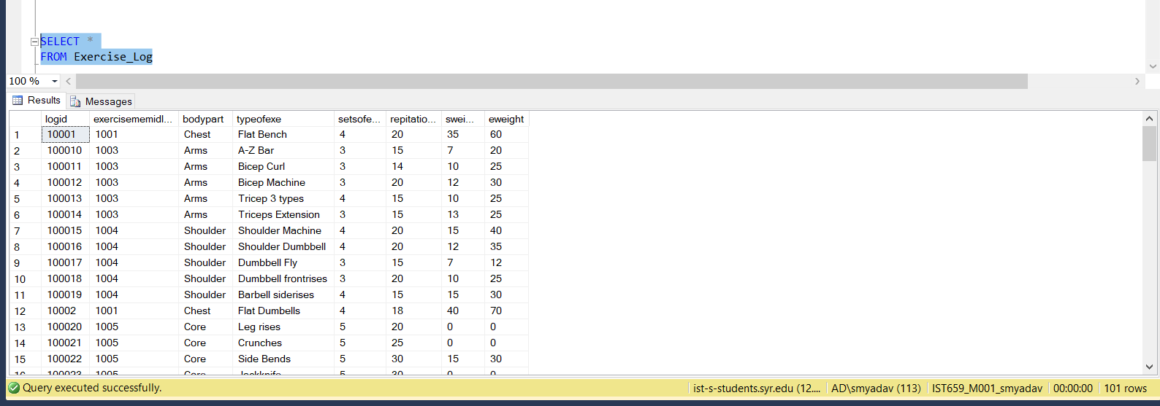

INSERT INTO Nutrition_Plan(nutritionid, memmedicalidplan, dayweekplan, instructionspalan) VALUES

('100000', '101', 'Monday', 'Breakfast -- Milk Biscuts, Lunch -- Subway S/W, Dinner -- Eggs Preparations')

INSERT INTO Nutrition_Plan(nutritionid, memmedicalidplan, dayweekplan, instructionspalan) VALUES

('100001', '101', 'Tuesday', 'Breakfast -- Water, Lunch -- Subway S/W, Dinner -- Salad')

INSERT INTO Nutrition_Plan(nutritionid, memmedicalidplan, dayweekplan, instructionspalan) VALUES

('100002', '101', 'Wednesday', 'Breakfast -- Chicken, Lunch -- Subway S/W, Dinner -- Salmon')

INSERT INTO Nutrition_Plan(nutritionid, memmedicalidplan, dayweekplan, instructionspalan) VALUES

('100003', '101', 'Thursday', 'Breakfast -- Water, Lunch -- Maggi, Dinner -- Salad')

INSERT INTO Nutrition_Plan(nutritionid, memmedicalidplan, dayweekplan, instructionspalan) VALUES

('100004', '101', 'Friday', 'Breakfast -- Dosa, Lunch -- Maggi, Dinner -- Salad')

INSERT INTO Nutrition_Plan(nutritionid, memmedicalidplan, dayweekplan, instructionspalan) VALUES

('100005', '101', 'Saturday', 'Breakfast -- Water, Lunch -- Eggs, Dinner -- Salad')

INSERT INTO Nutrition_Plan(nutritionid, memmedicalidplan, dayweekplan, instructionspalan) VALUES

('100006', '101', 'Sunday', 'Breakfast -- Water, Lunch -- Eggs, Dinner -- Subway S/W')

SELECT *

FROM Nutrition_Plan

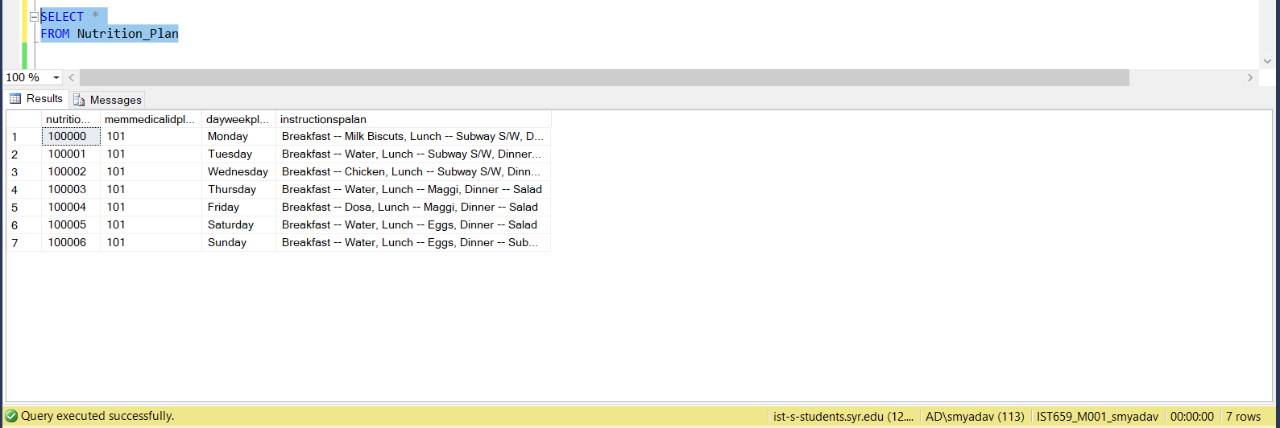

INSERT INTO Nutrition_Member(neutrationmemid, memmedicalidplan2, datetimesplan, dayweekplan) VALUES

('100001', '101', '2018-10-03 19:01:45.000', 'Monday')

INSERT INTO Nutrition_Member(neutrationmemid, memmedicalidplan2, datetimesplan, dayweekplan) VALUES

('100002', '102', '2018-10-03 9:30:40.000', 'Monday')

INSERT INTO Nutrition_Member(neutrationmemid, memmedicalidplan2, datetimesplan, dayweekplan) VALUES

('100003', '103', '2018-10-03 8:33:01.000', 'Monday')

INSERT INTO Nutrition_Member(neutrationmemid, memmedicalidplan2, datetimesplan, dayweekplan) VALUES

('100004', '104', '2018-10-03 8:33:01.000', 'Monday')

INSERT INTO Nutrition_Member(neutrationmemid, memmedicalidplan2, datetimesplan, dayweekplan) VALUES

('100005', '105', '2018-10-03 8:33:01.000', 'Monday')

INSERT INTO Nutrition_Member(neutrationmemid, memmedicalidplan2, datetimesplan, dayweekplan) VALUES

('100006', '106', '2018-10-03 9:37:11.000', 'Monday')

INSERT INTO Nutrition_Member(neutrationmemid, memmedicalidplan2, datetimesplan, dayweekplan) VALUES

('100007', '107', '2018-10-03 8:13:55.000', 'Monday')

INSERT INTO Nutrition_Member(neutrationmemid, memmedicalidplan2, datetimesplan, dayweekplan) VALUES

('100008', '108', '2018-10-03 10:54:59.000', 'Monday')

INSERT INTO Nutrition_Member(neutrationmemid, memmedicalidplan2, datetimesplan, dayweekplan) VALUES

('100009', '109', '2018-10-03 8:39:34.000', 'Monday')

INSERT INTO Nutrition_Member(neutrationmemid, memmedicalidplan2, datetimesplan, dayweekplan) VALUES

('1000010', '110', '2018-10-03 8:39:34.000', 'Monday')

INSERT INTO Nutrition_Member(neutrationmemid, memmedicalidplan2, datetimesplan, dayweekplan) VALUES

('1000011', '111', '2018-10-03 9:49:58.000', 'Monday')

INSERT INTO Nutrition_Member(neutrationmemid, memmedicalidplan2, datetimesplan, dayweekplan) VALUES

('1000012', '101', '2018-10-04 9:01:45.000', 'Tuesday')

INSERT INTO Nutrition_Member(neutrationmemid, memmedicalidplan2, datetimesplan, dayweekplan) VALUES

('1000013', '101', '2018-10-05 9:10:45.000', 'Wednesday')

INSERT INTO Nutrition_Member(neutrationmemid, memmedicalidplan2, datetimesplan, dayweekplan) VALUES

('1000014', '101', '2018-10-06 9:20:45.000', 'Thursday')

INSERT INTO Nutrition_Member(neutrationmemid, memmedicalidplan2, datetimesplan, dayweekplan) VALUES

('1000015', '101', '2018-10-07 9:00:45.000', 'Friday')

INSERT INTO Nutrition_Member(neutrationmemid, memmedicalidplan2, datetimesplan, dayweekplan) VALUES

('1000016', '101', '2018-10-07 9:45:45.000', 'Saturday')

INSERT INTO Nutrition_Member(neutrationmemid, memmedicalidplan2, datetimesplan, dayweekplan) VALUES

('1000017', '101', '2018-10-07 10:00:45.000', 'Sunday')

INSERT INTO Nutrition_Member(neutrationmemid, memmedicalidplan2, datetimesplan, dayweekplan) VALUES

('1000018', '102', '2018-10-04 8:01:45.000', 'Tuesday')

INSERT INTO Nutrition_Member(neutrationmemid, memmedicalidplan2, datetimesplan, dayweekplan) VALUES

('1000019', '102', '2018-10-05 8:10:45.000', 'Wednesday')

INSERT INTO Nutrition_Member(neutrationmemid, memmedicalidplan2, datetimesplan, dayweekplan) VALUES

('1000020', '102', '2018-10-06 8:20:45.000', 'Thursday')

INSERT INTO Nutrition_Member(neutrationmemid, memmedicalidplan2, datetimesplan, dayweekplan) VALUES

('1000021', '102', '2018-10-07 8:00:45.000', 'Friday')

INSERT INTO Nutrition_Member(neutrationmemid, memmedicalidplan2, datetimesplan, dayweekplan) VALUES

('1000022', '102', '2018-10-07 8:45:45.000', 'Saturday')

INSERT INTO Nutrition_Member(neutrationmemid, memmedicalidplan2, datetimesplan, dayweekplan) VALUES

('1000023', '102', '2018-10-07 9:00:45.000', 'Sunday')

SELECT *

FROM Nutrition_Member

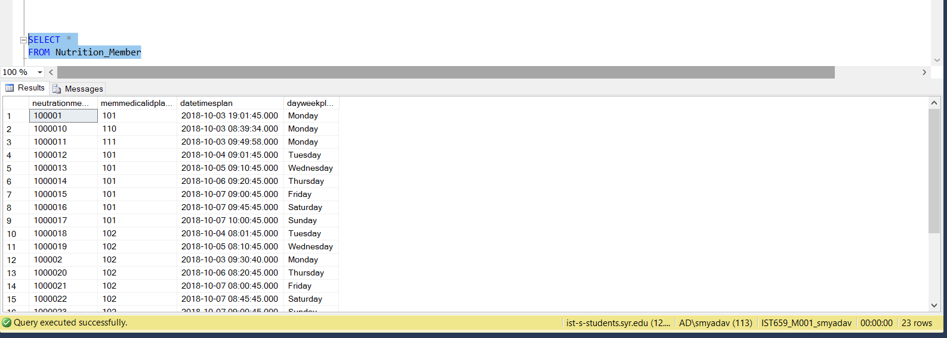

INSERT INTO Nutrition_Log(logidnu, nutritionmemidlog, typeofmeal, nameofmeal, calories, timenow) VALUES

('1', '100001', 'Breakfast', 'boiled eggs+bread', 400, '9:04')

INSERT INTO Nutrition_Log(logidnu, nutritionmemidlog, typeofmeal, nameofmeal, calories, timenow) VALUES

('2', '100001', 'Lunch', 'nuggets', 766, '14:30')

INSERT INTO Nutrition_Log(logidnu, nutritionmemidlog, typeofmeal, nameofmeal, calories, timenow) VALUES

('3', '100001', 'Dinner', 'Dal Chappati+Rice', 879, '22:40')

INSERT INTO Nutrition_Log(logidnu, nutritionmemidlog, typeofmeal, nameofmeal, calories, timenow) VALUES

('4', '100002', 'Breakfast', 'boiled chicken+grilled s/w', 589, '9:30')

INSERT INTO Nutrition_Log(logidnu, nutritionmemidlog, typeofmeal, nameofmeal, calories, timenow) VALUES

('5', '100002', 'Lunch', 'white rice+black beans+chicken wrap', 847, '15:10')

INSERT INTO Nutrition_Log(logidnu, nutritionmemidlog, typeofmeal, nameofmeal, calories, timenow) VALUES

('6', '100002', 'Dinner', 'Green Salad', 200, '21:50')

INSERT INTO Nutrition_Log(logidnu, nutritionmemidlog, typeofmeal, nameofmeal, calories, timenow) VALUES

('7', '100003', 'Breakfast', 'milk+biscuts', 485, '8:33')

INSERT INTO Nutrition_Log(logidnu, nutritionmemidlog, typeofmeal, nameofmeal, calories, timenow) VALUES

('8', '100003', 'Lunch', 'grilled chicken s/w+chicken wrap', 900, '15:10')

INSERT INTO Nutrition_Log(logidnu, nutritionmemidlog, typeofmeal, nameofmeal, calories, timenow) VALUES

('9', '100003', 'Dinner', 'Green Salad', 200, '21:50')

INSERT INTO Nutrition_Log(logidnu, nutritionmemidlog, typeofmeal, nameofmeal, calories, timenow) VALUES

('10', '100004', 'Breakfast', 'Green Salad', 485, '8:33')

INSERT INTO Nutrition_Log(logidnu, nutritionmemidlog, typeofmeal, nameofmeal, calories, timenow) VALUES

('11', '100004', 'Lunch', 'chicken wrap', 651, '14:10')

INSERT INTO Nutrition_Log(logidnu, nutritionmemidlog, typeofmeal, nameofmeal, calories, timenow) VALUES

('12', '100004', 'Dinner', 'grilled chicken s/w', 437, '22:55')

INSERT INTO Nutrition_Log(logidnu, nutritionmemidlog, typeofmeal, nameofmeal, calories, timenow) VALUES

('13', '100005', 'Breakfast', 'milk+biscuts', 485, '8:33')

INSERT INTO Nutrition_Log(logidnu, nutritionmemidlog, typeofmeal, nameofmeal, calories, timenow) VALUES

('14', '100005', 'Lunch', 'Green Salad', 651, '12:10')

INSERT INTO Nutrition_Log(logidnu, nutritionmemidlog, typeofmeal, nameofmeal, calories, timenow) VALUES

('15', '100005', 'Dinner', 'boiled chicken+grilled s/w', 437, '20:55')

INSERT INTO Nutrition_Log(logidnu, nutritionmemidlog, typeofmeal, nameofmeal, calories, timenow) VALUES

('16', '100006', 'Breakfast', 'brown rice+potatoes', 660, '9:37')

INSERT INTO Nutrition_Log(logidnu, nutritionmemidlog, typeofmeal, nameofmeal, calories, timenow) VALUES

('17', '100006', 'Lunch', 'Broccoli soup+brown rice', 420, '15:17')

INSERT INTO Nutrition_Log(logidnu, nutritionmemidlog, typeofmeal, nameofmeal, calories, timenow) VALUES

('18', '100006', 'Dinner', 'vegitable rice', 548, '23:14')

INSERT INTO Nutrition_Log(logidnu, nutritionmemidlog, typeofmeal, nameofmeal, calories, timenow) VALUES

('19', '100007', 'Breakfast', 'yogurt+flax seeds+cerials', 600, '8:13')

INSERT INTO Nutrition_Log(logidnu, nutritionmemidlog, typeofmeal, nameofmeal, calories, timenow) VALUES

('20', '100007', 'Lunch', 'lamb+chappati+salad', 589, '15:17')

INSERT INTO Nutrition_Log(logidnu, nutritionmemidlog, typeofmeal, nameofmeal, calories, timenow) VALUES

('21', '100007', 'Dinner', 'Green Salad', 200, '23:14')

INSERT INTO Nutrition_Log(logidnu, nutritionmemidlog, typeofmeal, nameofmeal, calories, timenow) VALUES

('22', '100008', 'Breakfast', 'chicken+salad', 573, '10:54')

INSERT INTO Nutrition_Log(logidnu, nutritionmemidlog, typeofmeal, nameofmeal, calories, timenow) VALUES

('23', '100008', 'Lunch', 'Green Salad+yogurt+brown rice', 600, '15:17')

INSERT INTO Nutrition_Log(logidnu, nutritionmemidlog, typeofmeal, nameofmeal, calories, timenow) VALUES

('24', '100008', 'Dinner', 'Broccoli soup+brown rice', 3389, '23:14')

INSERT INTO Nutrition_Log(logidnu, nutritionmemidlog, typeofmeal, nameofmeal, calories, timenow) VALUES

('25', '100009', 'Breakfast', 'green salad', 573, '8:39')

INSERT INTO Nutrition_Log(logidnu, nutritionmemidlog, typeofmeal, nameofmeal, calories, timenow) VALUES

('26', '100009', 'Lunch', 'Green Salad+brown rice', 600, '14:57')

INSERT INTO Nutrition_Log(logidnu, nutritionmemidlog, typeofmeal, nameofmeal, calories, timenow) VALUES

('27', '100009', 'Dinner', 'Broccoli soup+brown rice+yogurt', 3389, '22:39')

INSERT INTO Nutrition_Log(logidnu, nutritionmemidlog, typeofmeal, nameofmeal, calories, timenow) VALUES

('28', '1000010', 'Breakfast', 'green salad+chicken', 573, '8:39')

INSERT INTO Nutrition_Log(logidnu, nutritionmemidlog, typeofmeal, nameofmeal, calories, timenow) VALUES

('29', '1000010', 'Lunch', 'Green Salad', 200, '14:57')

INSERT INTO Nutrition_Log(logidnu, nutritionmemidlog, typeofmeal, nameofmeal, calories, timenow) VALUES

('30', '1000010', 'Dinner', 'Broccoli soup+brown rice+yogurt', 672, '22:39')

INSERT INTO Nutrition_Log(logidnu, nutritionmemidlog, typeofmeal, nameofmeal, calories, timenow) VALUES

('31', '1000011', 'Breakfast', 'chicken+yogurt', 593, '9:45')

INSERT INTO Nutrition_Log(logidnu, nutritionmemidlog, typeofmeal, nameofmeal, calories, timenow) VALUES

('32', '1000011', 'Lunch', 'Green Salad+Brown Rice', 621, '14:57')

INSERT INTO Nutrition_Log(logidnu, nutritionmemidlog, typeofmeal, nameofmeal, calories, timenow) VALUES

('33', '1000011', 'Dinner', 'Broccoli soup+yogurt', 734, '22:49')

INSERT INTO Nutrition_Log(logidnu, nutritionmemidlog, typeofmeal, nameofmeal, calories, timenow) VALUES

('34', '1000012', 'Breakfast', 'green salad+chicken', 573, '8:39')

INSERT INTO Nutrition_Log(logidnu, nutritionmemidlog, typeofmeal, nameofmeal, calories, timenow) VALUES

('35', '1000012', 'Lunch', 'Green Salad', 200, '14:57')

INSERT INTO Nutrition_Log(logidnu, nutritionmemidlog, typeofmeal, nameofmeal, calories, timenow) VALUES

('36', '1000012', 'Dinner', 'Broccoli soup+brown rice+yogurt', 672, '22:39')

INSERT INTO Nutrition_Log(logidnu, nutritionmemidlog, typeofmeal, nameofmeal, calories, timenow) VALUES

('37', '1000013', 'Breakfast', 'chicken+yogurt', 593, '9:45')

INSERT INTO Nutrition_Log(logidnu, nutritionmemidlog, typeofmeal, nameofmeal, calories, timenow) VALUES

('38', '1000013', 'Lunch', 'Green Salad+Brown Rice', 621, '14:57')

INSERT INTO Nutrition_Log(logidnu, nutritionmemidlog, typeofmeal, nameofmeal, calories, timenow) VALUES

('39', '1000013', 'Dinner', 'Broccoli soup+yogurt', 734, '22:49')

INSERT INTO Nutrition_Log(logidnu, nutritionmemidlog, typeofmeal, nameofmeal, calories, timenow) VALUES

('40', '1000014', 'Breakfast', 'boiled chicken+grilled s/w', 589, '9:30')

INSERT INTO Nutrition_Log(logidnu, nutritionmemidlog, typeofmeal, nameofmeal, calories, timenow) VALUES

('41', '1000014', 'Lunch', 'white rice+black beans+chicken wrap', 847, '15:10')

INSERT INTO Nutrition_Log(logidnu, nutritionmemidlog, typeofmeal, nameofmeal, calories, timenow) VALUES

('42', '1000014', 'Dinner', 'Green Salad', 200, '21:50')

INSERT INTO Nutrition_Log(logidnu, nutritionmemidlog, typeofmeal, nameofmeal, calories, timenow) VALUES

('43', '1000015', 'Breakfast', 'milk+biscuts', 485, '8:33')

INSERT INTO Nutrition_Log(logidnu, nutritionmemidlog, typeofmeal, nameofmeal, calories, timenow) VALUES

('44', '1000015', 'Lunch', 'grilled chicken s/w+chicken wrap', 900, '15:10')

INSERT INTO Nutrition_Log(logidnu, nutritionmemidlog, typeofmeal, nameofmeal, calories, timenow) VALUES

('45', '1000015', 'Dinner', 'Green Salad', 200, '21:50')

INSERT INTO Nutrition_Log(logidnu, nutritionmemidlog, typeofmeal, nameofmeal, calories, timenow) VALUES

('46', '1000016', 'Breakfast', 'green salad', 438, '8:39')

INSERT INTO Nutrition_Log(logidnu, nutritionmemidlog, typeofmeal, nameofmeal, calories, timenow) VALUES

('47', '1000015', 'Lunch', 'Green Salad+brown rice', 673, '13:57')

INSERT INTO Nutrition_Log(logidnu, nutritionmemidlog, typeofmeal, nameofmeal, calories, timenow) VALUES

('48', '1000015', 'Dinner', 'Broccoli soup+brown rice+yogurt', 830, '21:39')

INSERT INTO Nutrition_Log(logidnu, nutritionmemidlog, typeofmeal, nameofmeal, calories, timenow) VALUES

('49', '1000016', 'Breakfast', 'brown rice+potatoes', 660, '9:37')

INSERT INTO Nutrition_Log(logidnu, nutritionmemidlog, typeofmeal, nameofmeal, calories, timenow) VALUES

('50', '1000016', 'Lunch', 'Broccoli soup+brown rice', 420, '15:17')

INSERT INTO Nutrition_Log(logidnu, nutritionmemidlog, typeofmeal, nameofmeal, calories, timenow) VALUES

('51', '1000016', 'Dinner', 'vegitable rice', 548, '23:14')

INSERT INTO Nutrition_Log(logidnu, nutritionmemidlog, typeofmeal, nameofmeal, calories, timenow) VALUES

('52', '1000017', 'Breakfast', 'chicken+yogurt', 593, '9:45')

INSERT INTO Nutrition_Log(logidnu, nutritionmemidlog, typeofmeal, nameofmeal, calories, timenow) VALUES

('53', '1000017', 'Lunch', 'Green Salad+Brown Rice', 621, '14:57')

INSERT INTO Nutrition_Log(logidnu, nutritionmemidlog, typeofmeal, nameofmeal, calories, timenow) VALUES

('54', '1000017', 'Dinner', 'Broccoli soup+yogurt', 734, '22:49')

INSERT INTO Nutrition_Log(logidnu, nutritionmemidlog, typeofmeal, nameofmeal, calories, timenow) VALUES

('55', '1000018', 'Breakfast', 'milk+biscuts', 485, '8:33')

INSERT INTO Nutrition_Log(logidnu, nutritionmemidlog, typeofmeal, nameofmeal, calories, timenow) VALUES

('56', '1000018', 'Lunch', 'grilled chicken s/w+chicken wrap', 900, '15:10')

INSERT INTO Nutrition_Log(logidnu, nutritionmemidlog, typeofmeal, nameofmeal, calories, timenow) VALUES

('57', '1000018', 'Dinner', 'Green Salad', 200, '21:50')

INSERT INTO Nutrition_Log(logidnu, nutritionmemidlog, typeofmeal, nameofmeal, calories, timenow) VALUES

('58', '1000019', 'Breakfast', 'Green Salad', 485, '8:33')

INSERT INTO Nutrition_Log(logidnu, nutritionmemidlog, typeofmeal, nameofmeal, calories, timenow) VALUES

('59', '1000019', 'Lunch', 'chicken wrap', 651, '14:10')

INSERT INTO Nutrition_Log(logidnu, nutritionmemidlog, typeofmeal, nameofmeal, calories, timenow) VALUES

('60', '1000019', 'Dinner', 'grilled chicken s/w', 437, '22:55')

INSERT INTO Nutrition_Log(logidnu, nutritionmemidlog, typeofmeal, nameofmeal, calories, timenow) VALUES

('61', '1000020', 'Breakfast', 'milk+biscuts', 485, '8:33')

INSERT INTO Nutrition_Log(logidnu, nutritionmemidlog, typeofmeal, nameofmeal, calories, timenow) VALUES

('62', '1000020', 'Lunch', 'grilled chicken s/w+chicken wrap', 900, '15:10')

INSERT INTO Nutrition_Log(logidnu, nutritionmemidlog, typeofmeal, nameofmeal, calories, timenow) VALUES

('63', '1000020', 'Dinner', 'Green Salad', 200, '21:50')

INSERT INTO Nutrition_Log(logidnu, nutritionmemidlog, typeofmeal, nameofmeal, calories, timenow) VALUES

('64', '1000021', 'Breakfast', 'boiled chicken+grilled s/w', 589, '9:30')

INSERT INTO Nutrition_Log(logidnu, nutritionmemidlog, typeofmeal, nameofmeal, calories, timenow) VALUES

('65', '1000021', 'Lunch', 'white rice+black beans+chicken wrap', 847, '15:10')

INSERT INTO Nutrition_Log(logidnu, nutritionmemidlog, typeofmeal, nameofmeal, calories, timenow) VALUES

('66', '1000021', 'Dinner', 'Green Salad', 200, '21:50')

INSERT INTO Nutrition_Log(logidnu, nutritionmemidlog, typeofmeal, nameofmeal, calories, timenow) VALUES

('67', '1000022', 'Breakfast', 'green salad', 438, '8:39')

INSERT INTO Nutrition_Log(logidnu, nutritionmemidlog, typeofmeal, nameofmeal, calories, timenow) VALUES

('68', '1000022', 'Lunch', 'Green Salad+brown rice', 673, '13:57')

INSERT INTO Nutrition_Log(logidnu, nutritionmemidlog, typeofmeal, nameofmeal, calories, timenow) VALUES

('69', '1000022', 'Dinner', 'Broccoli soup+brown rice+yogurt', 830, '21:39')

INSERT INTO Nutrition_Log(logidnu, nutritionmemidlog, typeofmeal, nameofmeal, calories, timenow) VALUES

('70', '1000023', 'Breakfast', 'green salad', 573, '8:39')

INSERT INTO Nutrition_Log(logidnu, nutritionmemidlog, typeofmeal, nameofmeal, calories, timenow) VALUES

('71', '1000023', 'Lunch', 'Green Salad+brown rice', 600, '14:57')

INSERT INTO Nutrition_Log(logidnu, nutritionmemidlog, typeofmeal, nameofmeal, calories, timenow) VALUES

('72', '1000023', 'Dinner', 'Broccoli soup+brown rice+yogurt', 3389, '22:39')

SELECT *

FROM Nutrition_Log

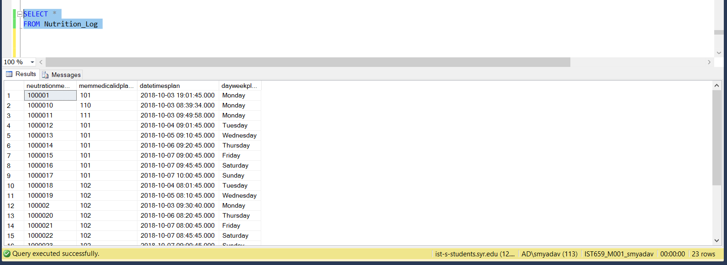

Interfaces

There are 3 types of users for this database.

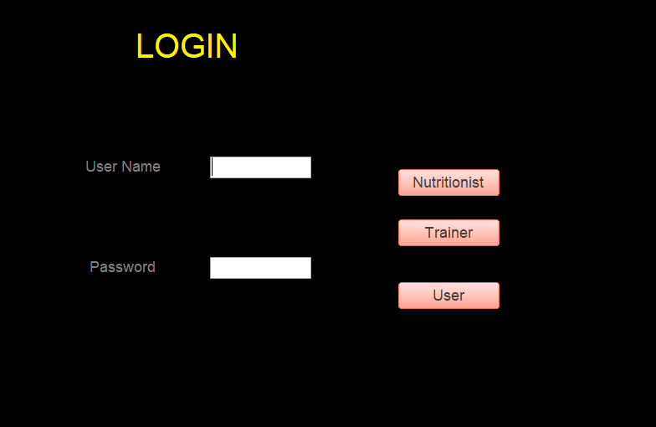

When the password for the User is correct it will direct one to this page.

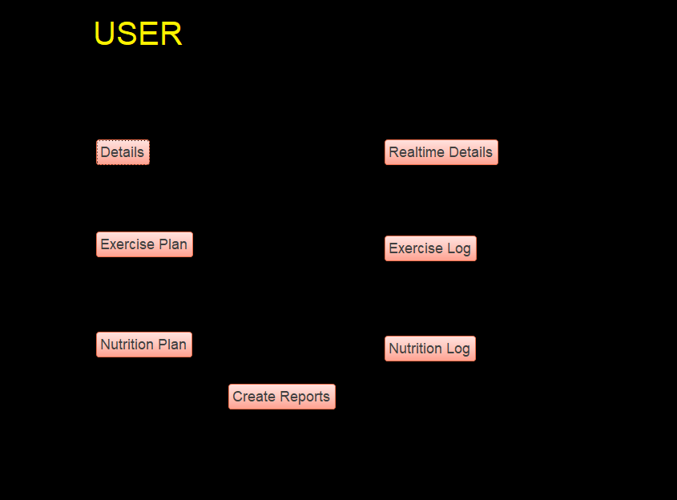

There are different options to choose from. One of those options allows the user to see his exercise log. This is what happens when one clicks the exercise log button.

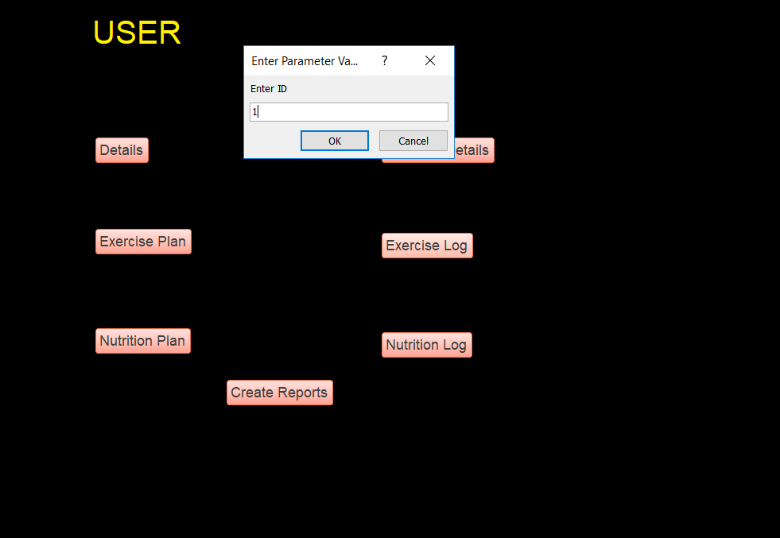

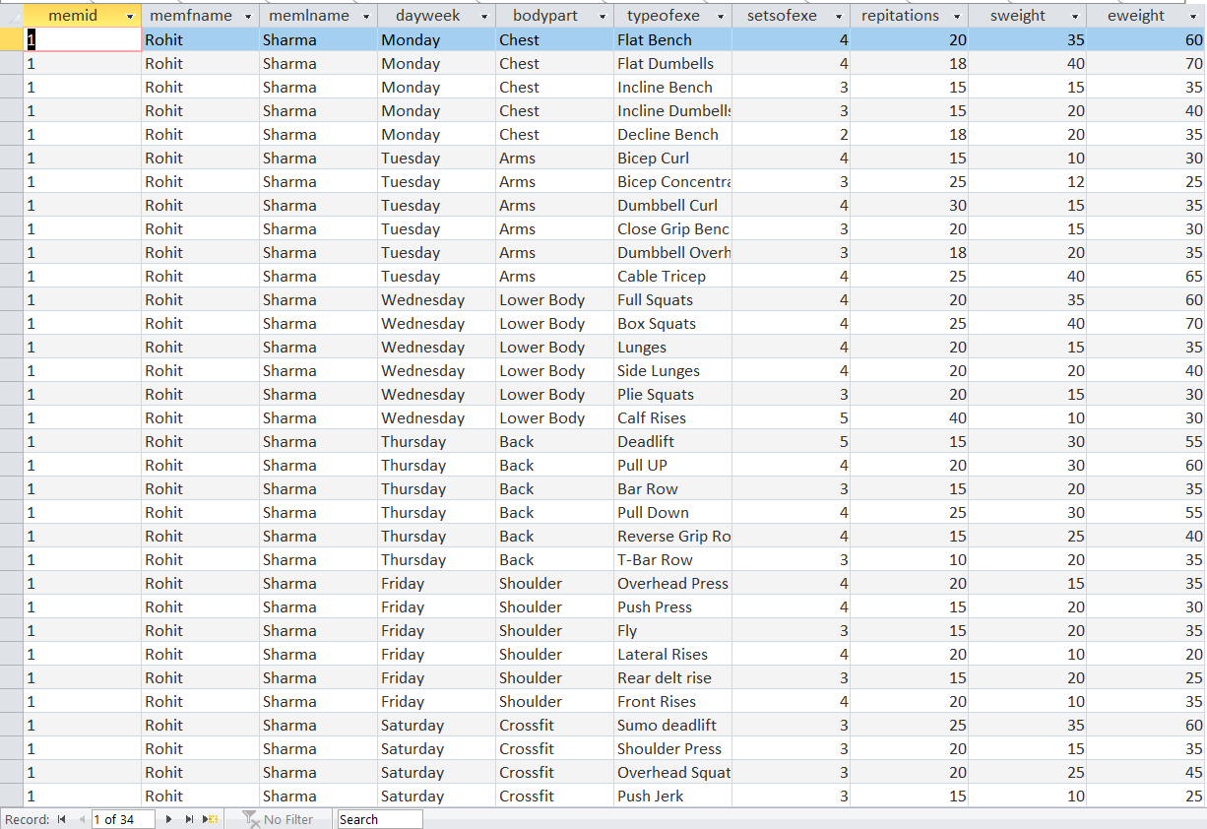

There is also a create form button which creates reports for different queries. When one clicks on the create report button you get directed to the next page.

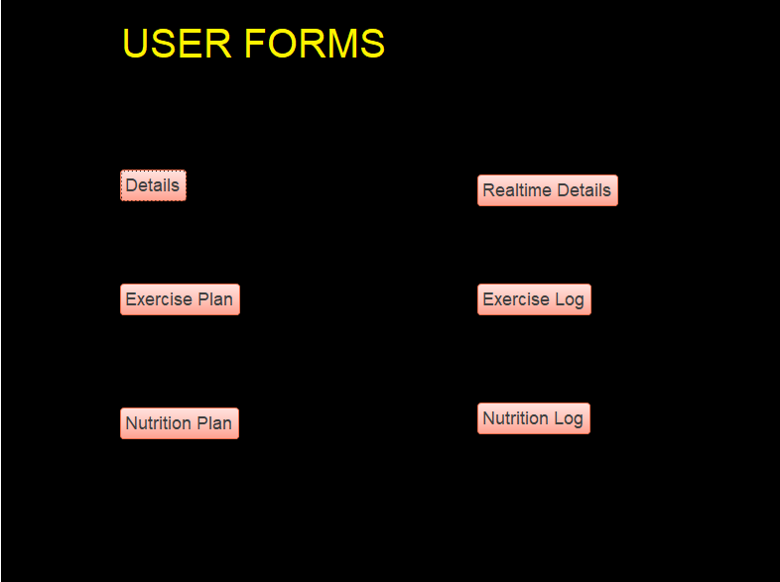

Clicking the Nutrition Plan gives you this.

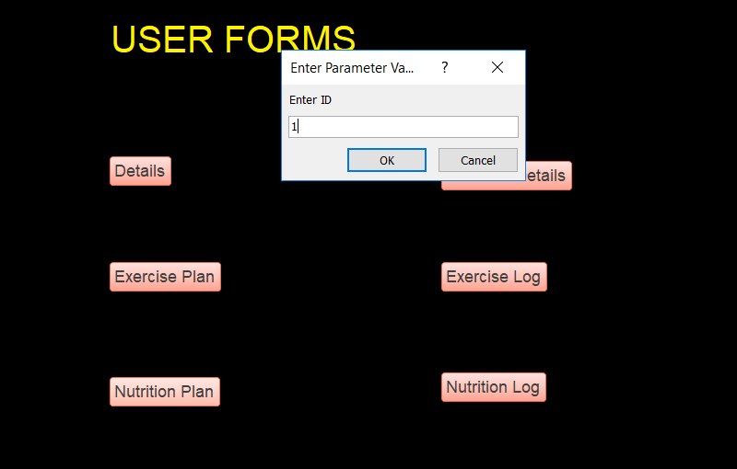

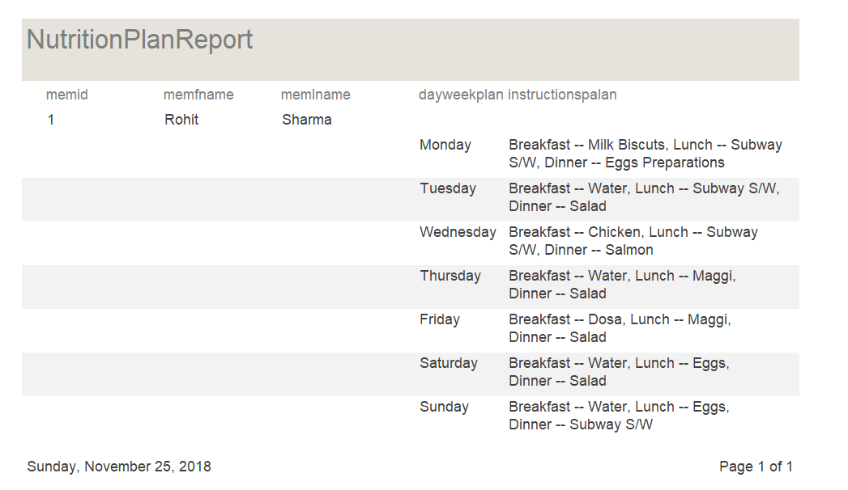

When the password for the Trainer is correct it will direct one to this page.

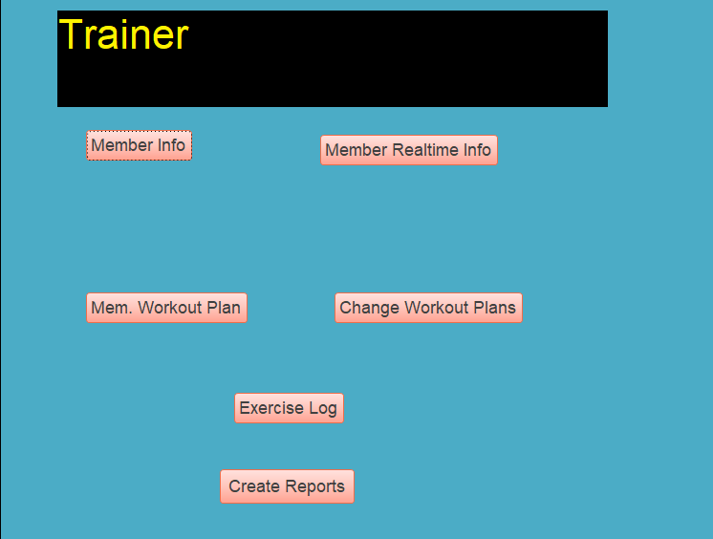

When the trainer clicks Mem. Workout Plan this pages apper.

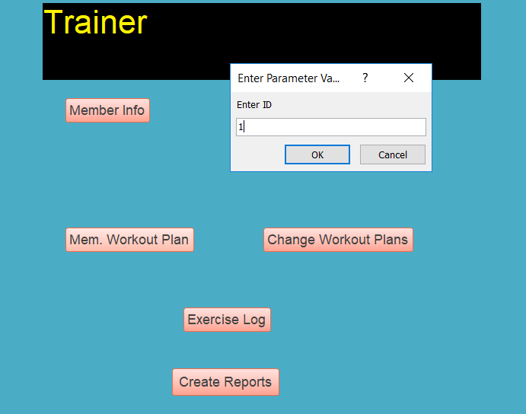

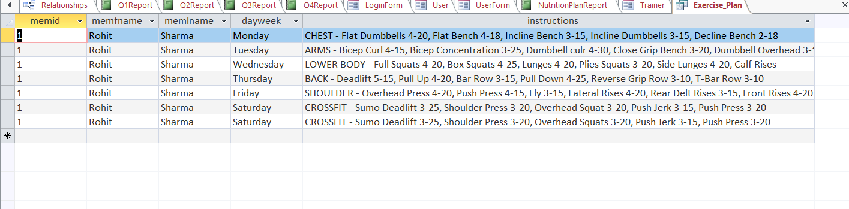

There is also a create form button which creates reports for different queries. When one clicks on the create report button you get directed to the next page.

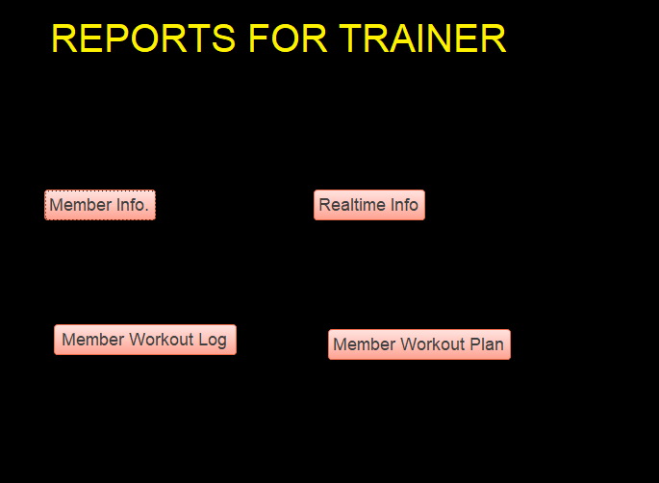

Clicking the Realtime Info gives you this.

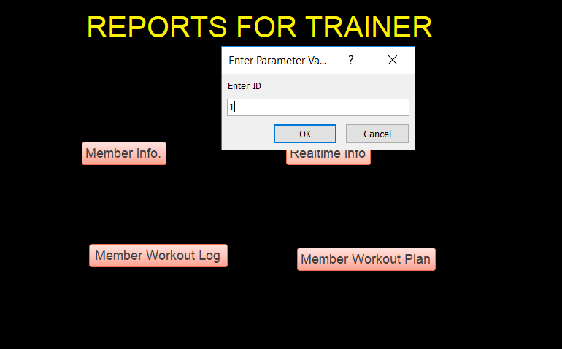

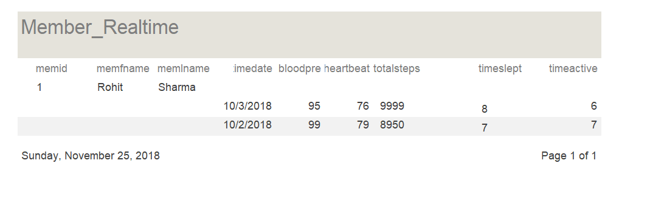

When the password for the Nutritionist is correct it will direct one to this page.

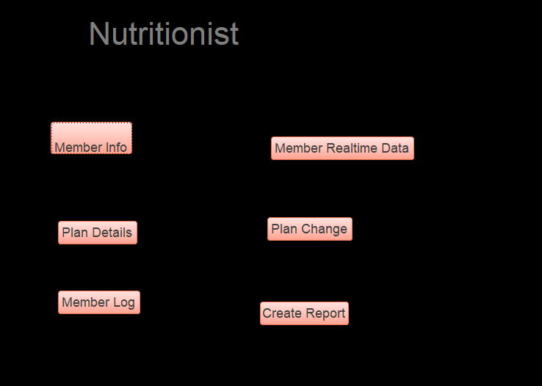

When the Nutritionist click Plan Details this is what appears:

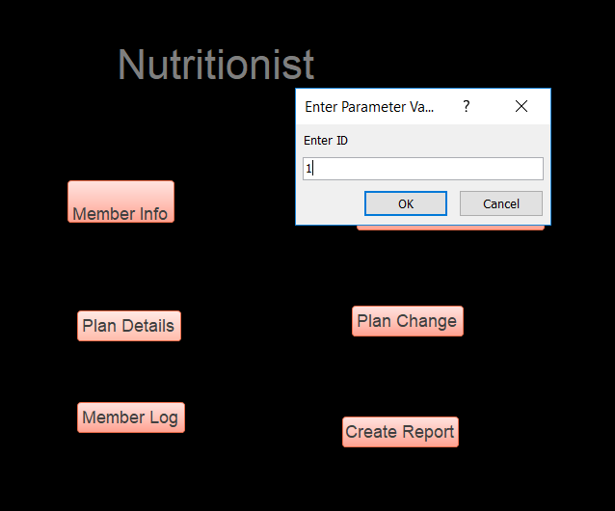

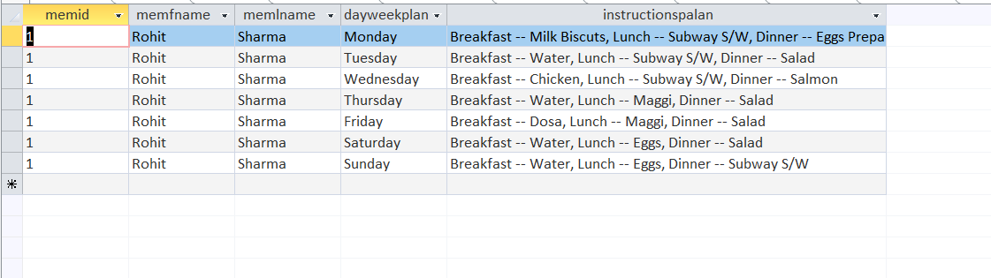

There is also a create form button which creates reports for different queries. When one clicks on the create report button you get directed to the next page.

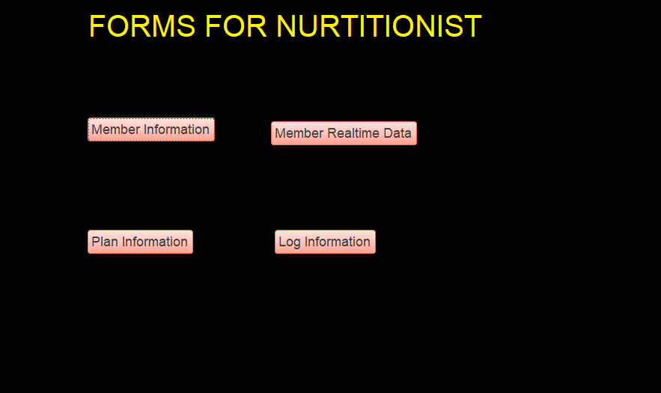

Clicking the Log Information gives you this.

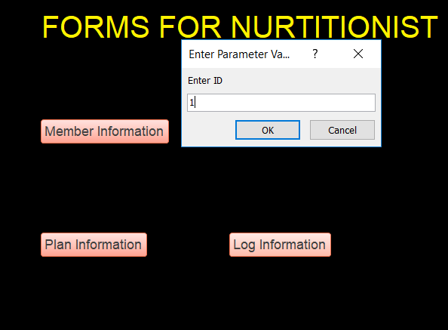

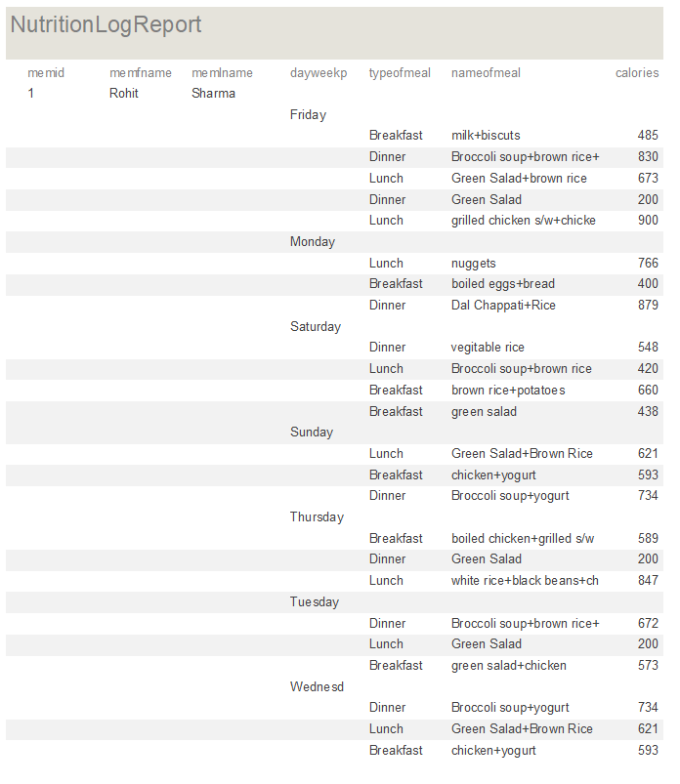

Reports:

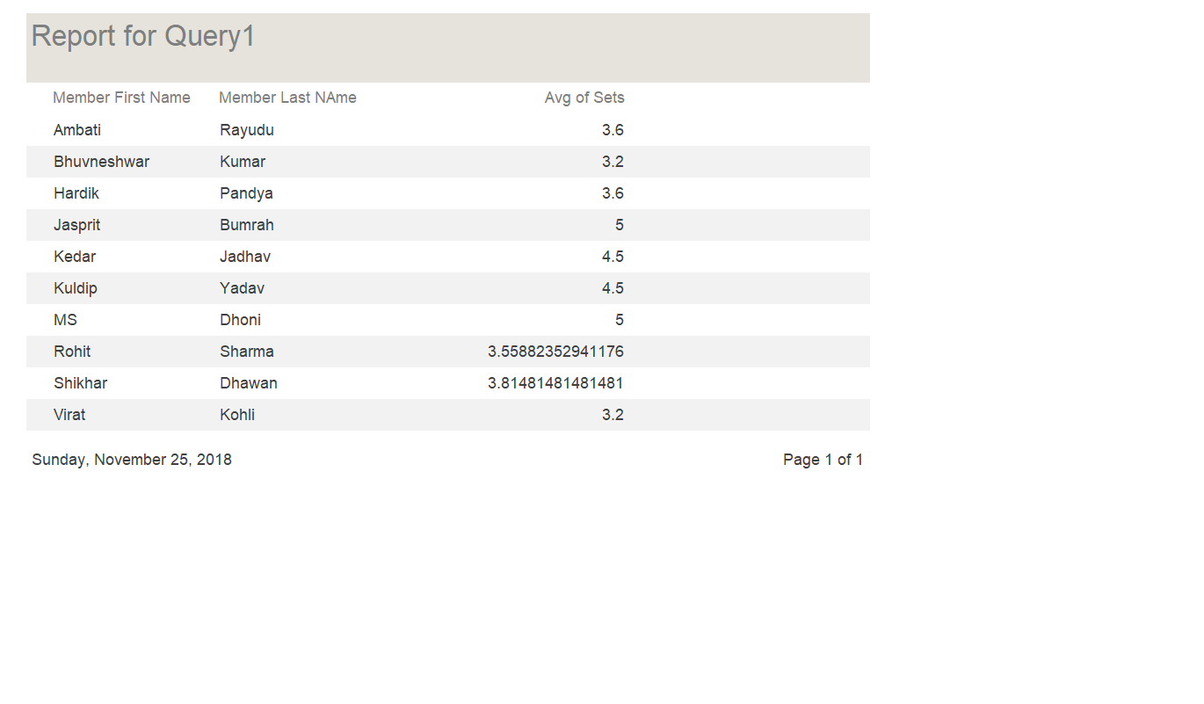

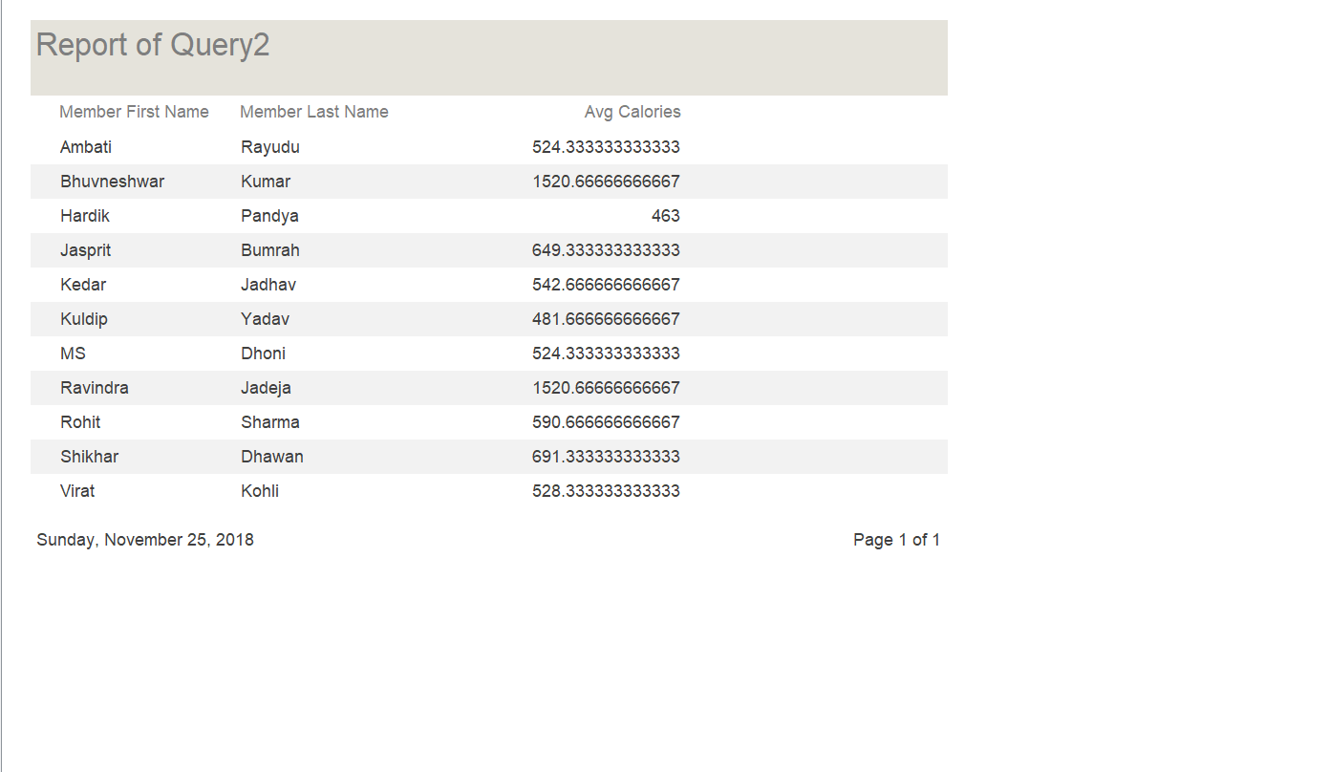

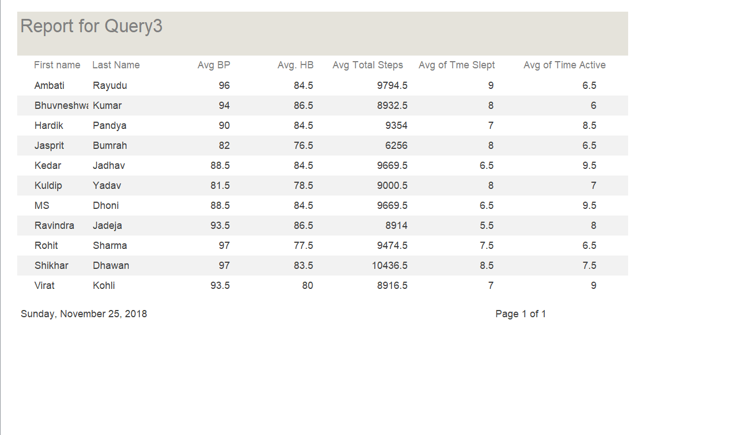

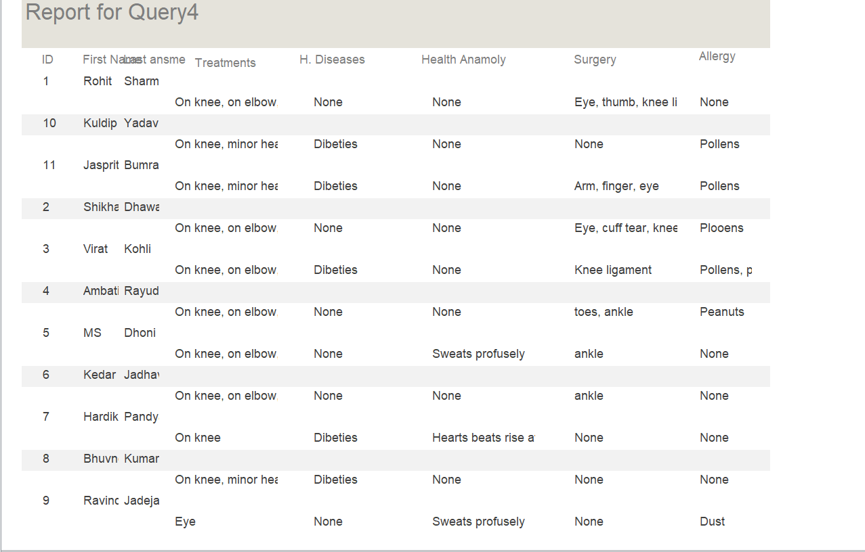

IMPROVEMENTS ON RECOMMENDATIONS

Added Navigation Buttons to Trainer and Nutritionist Forms:

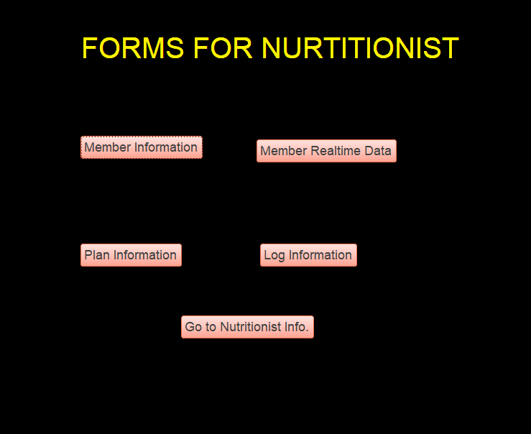

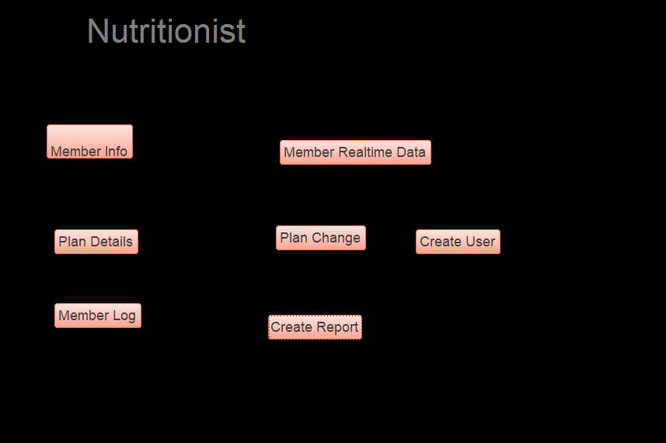

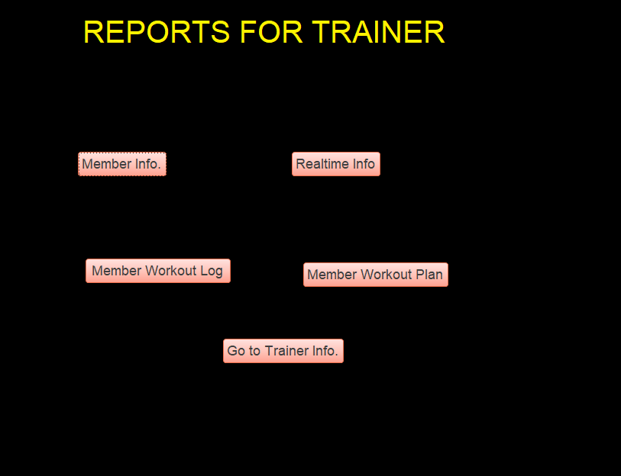

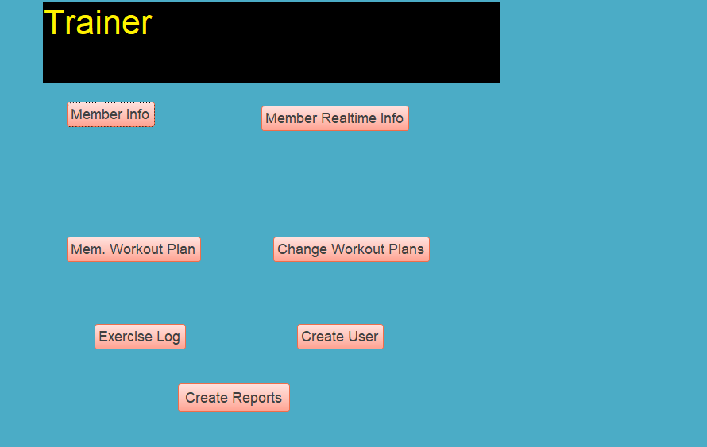

Added Add User button in Trainer and Nutritionist.

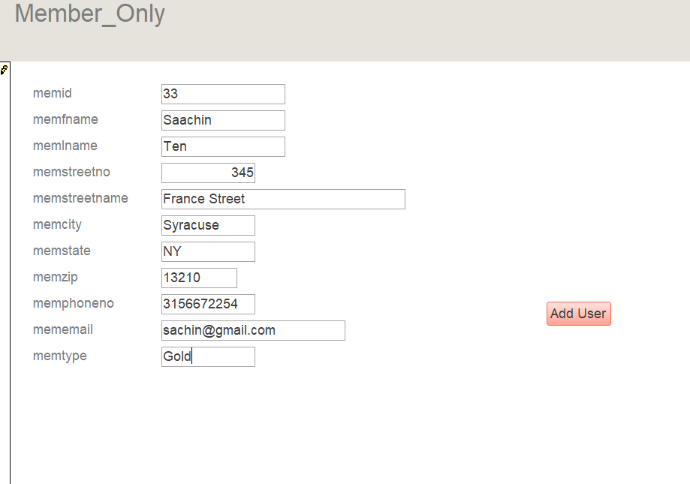

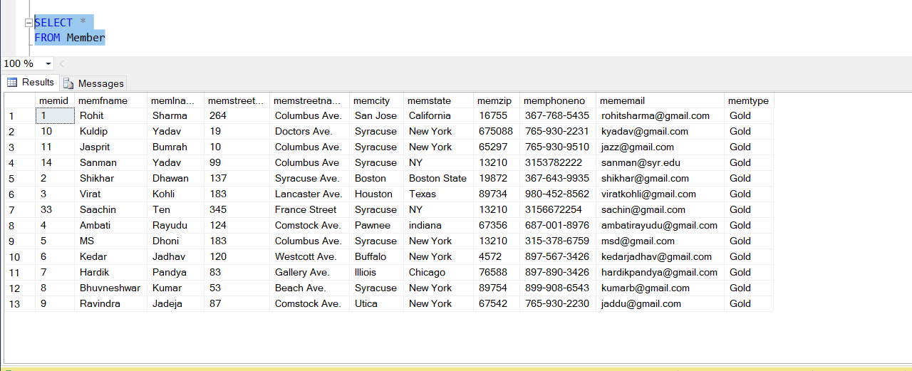

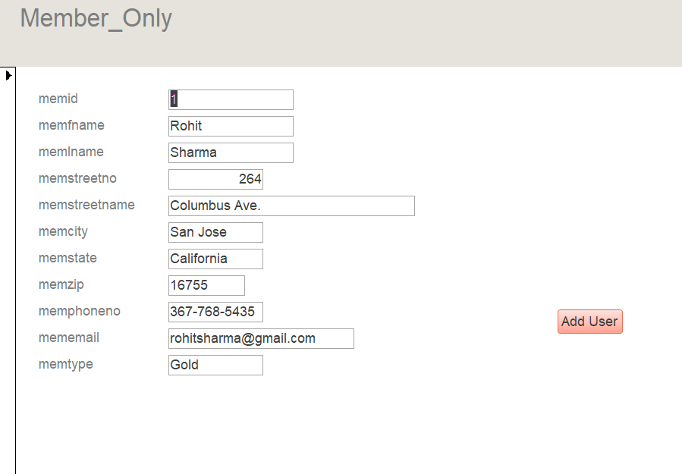

Updated search query to find users by last and first name instead of ID.

